Volunteer Application Form

Please complete and return this form to volunteers@solent.nhs.uk
or call us on: 0300 123 4013

Your details

Mr / Miss … | Title | Mr/Miss/Mrs/Ms/Other - please circle  or state:
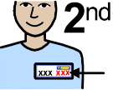 | * Surname
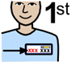 | * First Names
 | Preferred Name
 | * Address / Postcode
 | * Telephone
 | * Email
 | * Emergency Contact | (Name, Relationship, Telephone Number)

Your details

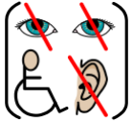 | Do you have a disability? | ☐ Yes ☐ No (please one)
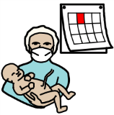 | *Date of Birth
 | How did you hear about volunteering for Solent NHS Trust?  (please one) | ☐ Trust website  ☐ Facebook  ☐ Twitter  ☐ Radio  ☐ Instagram  ☐ Member of staff  ☐ Family or friend  ☐ Other (please say):

* required information

Questions about you volunteering

What days of the week are you free?
What times are you free?
Where could you volunteer? (Portsmouth / Southampton / working from home)
What skills, knowledge or experience can you bring to Solent NHS Trust?

Why would you like to volunteer for Solent NHS Trust?
Give examples of things you have done that make you a good volunteer.
DBS | Do you have a DBS (Disclosure and Barring Service) check? | If yes, please write down the certificate number below and send us a copy of it with your application.  Certificate Number:
 | Do you have a car or other transport?
 | Do you have any health issues that might affect your volunteering?
 | Do you live with anyone who is at risk?

References

Please give the names and telephone numbers of two referees who have known you for at least 3 years.
We are asking for a personal character reference; it may be someone you have worked with, a friend or neighbour (they should know you well). If you have been in education or work in the last 3 years, ideally one of your referees should be a teacher or someone you worked with. Referees cannot be relatives.

Referee 1:

Mr / Miss … | Title
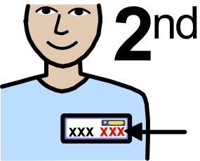 | * Surname
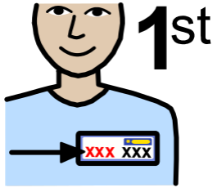 | * First Names
 | * Address
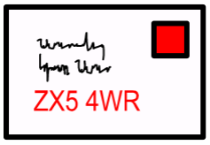 | * Post Code
 | * Telephone
 | Email
 | *Relationship to you

Referee 2:

Mr / Miss … | Title
 | * Surname
 | * First Names
 | * Address
 | * Post Code
 | * Telephone
 | Email
 | *Relationship to you

Thank you for your support, we could not do this without our volunteers.
Disclosure and Baring Service (DBS) form
Please note - This information will not be shared with the interviewer

Mr / Miss … | Title
 | Gender
 | First Name
 | Have you ever used another first name?
 | If yes, what were they and when did you use them? Please give dates.
 | Middle Names
 | Do you have other middle names?
If you have other middle names, what are they?
When have you used them (give dates)?
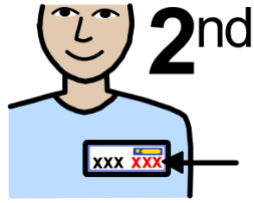 | Your surname
 | Have you ever used another surname?
 | If yes, what were they and when did you use them? Please give dates.
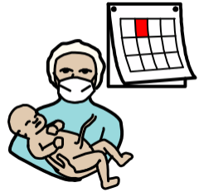 | Date of Birth
 | Were you born in the UK?
 | If no, please say where you were born.
 | Which town were you born in?
 | Which country were you born in?
 | Nationality
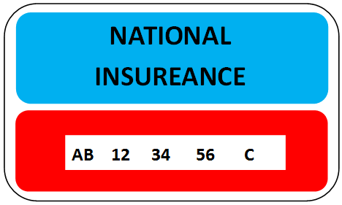 | National Insurance number
 | Your address
 | Your postcode
 | What date did you move to this address?
 | If you have lived here for less than 5 years, please tell us your other addresses in the last 5 years with dates.
 | Mobile number
 | Best time to call you
 | Email address
 | Do you have any convictions, cautions, reprimands or final warnings?

DBS application form consent
There is another part of this application which needs to be done online. If you would like Solent NHS Trust to do this for you please sign your name and date below. We will let you know when it has been done.
Your signature:
Today’s date:

Supporting information
Please send us 3 forms of identification. One must be photo identification (passport or driving licence). A photograph or scan of the identification is fine.

- A copy of your driving licence (if you have one)
- A copy of your passport or birth certificate
- Proof of your address (a household bill or bank statement from the last 6 months)
Please also send in:
- A picture of yourself for your identification (ID) Badge (a selfie picture is OK, if it is clear).
If you have had a Disclosure and Baring Service (DBS) check in the last 3 years, please take a picture of all of the certificate and send this to us. This can help speed up your application.

Occupation Health and Wellbeing Service – Health Assessment Form
Please note - This information will not be shared with the interviewer

About you
 | Name
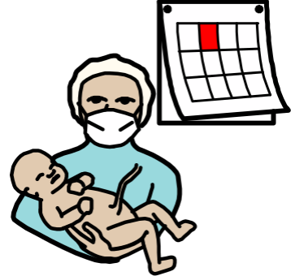 | Date of Birth
 | Address
 | Telephone number
 | Family Doctor / GP
 | GP Address
 | GP Telephone number
 | Your Emergency contact
 | Relationship to you
 | Emergency contact telephone number

Your health
 | Have you seen your GP or other health professional, for more than minor complaints, in the last year?  Please give details | Yes ☐ No ☐
 | Do you have any health problems that could  affect you in the workplace?  Please give details | Yes ☐ No☐
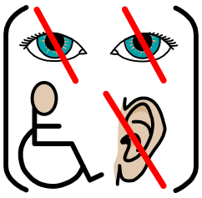 | Do you have any impairment which may need adjustments to be made in the workplace?  Please give details | Yes ☐ No ☐
 | Do you have any allergies?  Examples: medications, wasp/bee stings, latex, soaps etc.  Please give details | Yes ☐ No ☐

Tuberculosis (TB) Yes No
Have you ever had TB?

Do you have a productive cough?

Yes No
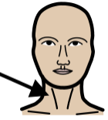 | Do you have swollen neck glands?
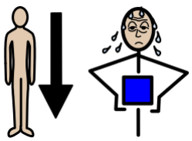 | Do you suffer weight loss, fatigue or  night sweats?
 | Do you have friends or family who have the TB symptoms above?
 | Have you recently moved to the UK?
 | Have you recently lived or worked in a TB endemic area for more than 3 months?

 | If you answered YES to any questions about TB above; please give details
 | Have you been in contact with any infectious diseases in the last 3 months? Like Measles or German Measles? | Yes ☐ No ☐
 | Have you had Chicken Pox? | Yes ☐ No ☐

Vaccinations – when did you last have these vaccinations? You may need to check with your GP. Please write the date of each vaccination.

Date of vaccination

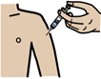 | Polio - This vaccination may be given as Diphtheria/Tetanus/Polio Name
 | Tetanus - This vaccination may be given as Diphtheria/Tetanus/Polio
 | Rubella - This vaccination may be given as MMR
 | BCG for TB

I declare the information I have given is correct
My signature:
Today’s date:

Code of Confidentiality Agreement, Data Protection and our Responsibilities to Non-Solent NHS Trust Employees

This information is for people who work with Solent NHS Trust as volunteers, students or on work experience or shadowing.

Code of Confidentiality
Whilst I am working with Solent NHS Trust I may work with confidential or sensitive information. This information might be about patients, carers, staff or Trust business.
I agree that I will not share or talk about this information now or after my work with Solent NHS Trust (unless I have the permission of the Chief Executive or another Senior Officer of the Trust).
I understand that if I do share this information, I can be reported to the Information Commissioner’s Office who enforces the Data Protection Act 2018 and other data protection regulations.
I understand that all confidential and sensitive information has rules about how it is used. These rules are in:
- The General Data Protection Regulations 2016,
- Caldicott Principles,
- Copyright Designs and Patients Act 1998,
- Computer Misuse Act 1990
- Freedom of Information Act 2000.

When I work with Solent NHS Trust, I will follow the Trust policies and procedures which are:
- Data Protection Compliance Policy
- Records Management Policy
- Information Request Policy
- Information Sharing Protocols
- NHS Code of Confidentiality

Sharing Patient information

I know there are rules about sharing patient information. I will obey the rules. If I am unsure about sharing patient information, I will ask my manager.
If I do not follow the rules I may lose my job. I may also face prosecution.

Agreement
I understand that I must follow all the rules the above. I will keep following these rules after I have stopped working with Solent NHS Trust.
My signature
My name

Today’s date

Please note – if you are under 18, please ask your parent or guardian to complete the Consent below.

I give permission for my child to do voluntary work for Solent NHS Trust:
Name of child

Name of Parent or Guardian
Today’s date

Signature

Monitoring Information
Please note - This information will not be shared with the interviewer

NHS organisations know that having a diverse workforce of volunteers is good.

We are committed to treating all employees and volunteers with dignity and respect.

It makes no difference what age, disability, gender reassignment, marriage and civil partnership, pregnancy and maternity, race, religion or belief, sex or sexual orientation you are.

We welcome applications from all sections of the community

About me
 | DOB
 | Gender |  | Male ☐
 |  |  | Female ☐
 |  |  | I don’t want to say ☐

My ethnic origin is
Asian or Asian British:
Bangladeshi
Indian
Pakistani
Any other Asian background

Black or Black British
African
Caribbean
Any other black background
Mixed
White and Asian
White and Black African
White and Black Caribbean
Any other mixed background
White
British
Irish
Any other White background
Other Ethnic Group
Chinese
Any other ethnic group
I do not want to say

My sexuality
Lesbian
Gay
Bisexual
Other
Heterosexual
I do not want to say

My religious belief
Atheism
Buddhism
Christianity
Islam
Jainism
Sikhism
Judaism
Hinduism
Other
I do not want to say

 | Do you have a disability? | Yes ☐ No ☐  I do not want to say ☐
Please tell us what type of disability or disabilities you have
 | Physical Impairment
 | Sensory Impairment
 | Mental Health Problem
 | Learning Disability or Difficulty
 | Long-standing Illness
 | Other

