**Our Green Plan**

2021/22 - 2024/25

**‘Care - for the future’**

**Contents**

EXECUTIVE SUMMARY…………………………………………………3

GLOSSARY……………………………………………………………………4

OUR IMPACTS- THE CASE FOR CHANGE……………………… 5

OUR GREEN PLAN ON A PAGE……………………………………..7

DELIVERING AND MONITORING THE PLAN………………….8

OUR CARE……………………………………………………………………9

OUR ESTATE……………………………………………………………….10

OUR SUPPLIES…………………………………………………………….12

OUR TRAVEL……………………………………………………………….13

OUR COMMUNITIES & OUR PEOPLE……………………………14

|  |  |  |
| --- | --- | --- |
| **Green Plan version** | **Publication date** | **Review date** |
| 1.01 | August 2021 | August 2022 |

|  |
| --- |
| **Contributors to this plan included our Solent NHS Trust:** |
| * Executives * Care teams * Estates and Facilities teams * Procurement team * Travel and transport team * Communications team * HR, Learning and Development teams * Finance team * Community liaison |
| ***With expert input from our external partners including community representatives*** |

If you have any comments on or questions about Our Green Plan please contact us at:

[sustainability@solent.nhs.uk](mailto:sustainability@solent.nhs.uk)

# **Care- for the Future**

**Care – for the future**

Our community health is dependent on a healthy environment.

There is a clear link between climate change and public health.

As a Trust we are dedicated to reducing our environmental impact, while delivering the best quality of care.

Working together to achieve our ‘greener’ targets will help ensure that we are creating the best environment possible for our people, patients, and our communities, for now and for the future’’



Andrew Strevens

**Chief Executive Officer**

# **Executive Summary**

The Climate Health Emergency is real and will impact the health and well-being of us all.

We have a collective responsibility to do more, and while we’ve made progress we can and should go further.

This includes thinking about how we can sustainably deliver all of our services, right down to the patient-facing models of clinical care that we deliver.

Our environmental impact, measured in our carbon footprint for 2020/21, amounted to 4,069 Tonnes CO2e. Our Green Plan sets out our approach to minimising, measuring and monitoring this impact. It focuses on:

**Our Care** – how we reduce our environmental impact by improving the way we deliver care e.g. offering digital care pathways where clinically appropriate, inhaler recycling, medicines and anaesthetic gases management.

**Our Estate**- to reduce the carbon emissions from our buildings, improve recycling and continue to adapt our buildings to future needs.

**Our Supplies**- to ensure that environmental standards such as emission reduction, are reflected in all of our contracts alongside introducing more social value.

**Our Travel**- to reduce our environmental impact by changing the way we deliver care, travel to work and in our day to day lives.

Delivery of this plan means a collective approach by all our people, together with our local community, and partners. As part of our role in the Integrated Care System for Hampshire & Isle of Wight, our Green Plan will be consolidated into a wider system- plan for 2022.

# **Glossary – some key terms used in this plan**

|  |  |
| --- | --- |
| **Active Travel** | Active travel simply means making journeys by physically active means - like walking, cycling, or scooting. |
| **Carbon Dioxide – CO2e** | ‘CO2e’, or Carbon Dioxide equivalent, is a standard unit for measuring carbon footprints - this expresses the impact of each different greenhouse gas in terms of the amount of CO2 that would create the same amount of warming. |
| **Circular Economy** | A circular economy is an economic system aimed at eliminating waste and enabling the continual use of resources. This includes ‘reuse’, ‘repair’, ‘refurbishment’, ‘remanufacturing’ as well as ‘recycling’, where relevant. It moves away from the current linear economy where we ‘make, use and dispose’, which results in significant waste and related emissions. |
| **Greenhouse gases** | The Earth’s greenhouses gases (GHGs) trap heat in the atmosphere and warm the planet. While this is a natural process, the greater the concentration of greenhouse gases the higher the temperature. They have increased significantly due to human activities and are continuing to do so, leading to major impacts on society, economy and the environment. The main GHGs (those focused on within international Climate Change agreements) are: Carbon Dioxide (CO2), Methane (CH4), Nitrogen Dioxide (N2O) and Hydro-fluorocarbons (HFCs), while others also apply. |
| **‘Net Zero’** | The UK Government has set a goal to be ‘carbon zero’ by 2050, which is enshrined in [law](http://www.legislation.gov.uk/ukdsi/2019/9780111187654). The NHS has set a goal to reach [net zero by 2040](https://www.england.nhs.uk/greenernhs/a-net-zero-nhs/).  ‘Net Zero’ emissions means: any emissions remaining, after all possible efforts to mitigate them have been undertaken, would be balanced by *verified* schemes to offset an equivalent amount of greenhouse gases from the atmosphere, such as planting trees or using technology like carbon capture and storage. *Only after all possible emissions have been mitigated, reflecting relevant cost benefit analysis, should offset be considered.* |
| **NOx and PM 2.5** | Nitrous Oxides and fine particles, a major source of which is road traffic, can cause air pollution and death and ill-health among communities. |
| **UN Sustainable Development Goals (SDGs)** | The 17 [Sustainable Development Goals](https://www.undp.org/content/undp/en/home/sustainable-development-goals.html#:~:text=The%20Sustainable%20Development%20Goals%20(SDGs,peace%20and%20prosperity%20by%202030.) (SDGs), also known as the Global Goals, were adopted by all United Nations Member States in 2015 as a universal call to action to end poverty, protect the planet and ensure that all people enjoy peace and prosperity by 2030. |

# 

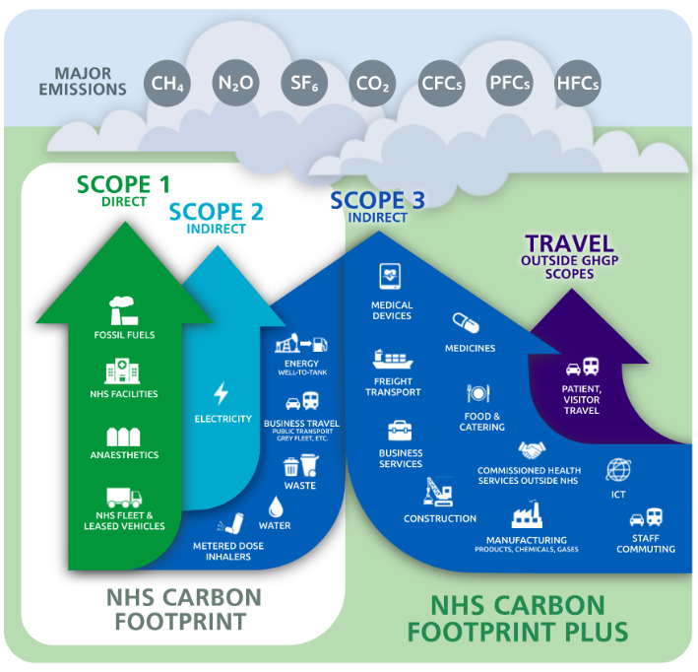**Our Impacts – the need for change**

The link from climate change to public health impacts and NHS resource pressures is clear. We have a significant impact on the environment, and we must seek to reduce this while delivering quality healthcare for our community.

While we affect the environment in various ways, our impact on the environment and that of the NHS is measured in our Carbon Footprint (Tonnes CO2e).

**NHS Carbon Footprint**

Directly controlled emissions arise from the use of energy and water, the generation of waste, the use of travel for Trust business and anaesthetic gases. These emissions account for our carbon footprint.

Our total NHS carbon footprint for **2020/21** was **4,069 Tonnes CO2e**, based on sites we control. That is the equivalent volume of 14,000 double decker buses.

In **2013** our carbon footprint was **5,596 Tonnes CO2e** (this excludes emissions from anaesthetic gases as data is not available and some data is estimated).

The significant reduction since 2013, in part reflects a 19% reduction in the size of the estate and a 32% reduction in patient activity numbers, due to changes in the community and mental health services provided, as well as efficiency measures undertaken.

The footprint for 2020/21 also reflects the impact of COVID-19 on healthcare service delivery. For example, there was a significant reduction in emissions from business travel in 2020/21, due to greater use of digital consultations.

Figure 1: NHS Carbon Footprint and Carbon Footprint Plus (source: [NHS](https://www.england.nhs.uk/greenernhs/a-net-zero-nhs/))

**NHS Carbon Footprint Plus**

Other emissions arise from our supply chain (from goods and services procured) and within our community, such as those arising from staff commuting and patient and visitor travel to our sites. While these are not all quantified, we recognise the necessity of seeking to influence a reduction in relevant emissions where we can.

**Our NHS Carbon Footprint (2020/21)**

**Setting targets**

|  |  |  |
| --- | --- | --- |
|  | Energy | 2,492 Tonnes CO2e |
|  | **Water** | 30 Tonnes CO2e |
|  | **Waste** | 9 Tonnes CO2e |
|  | **Business Travel** | 384 Tonnes CO2e |
|  | **Anaesthetic gases** | 1,184 Tonnes CO2e |
|  | **Total** | **4,069 Tonnes CO2e** |

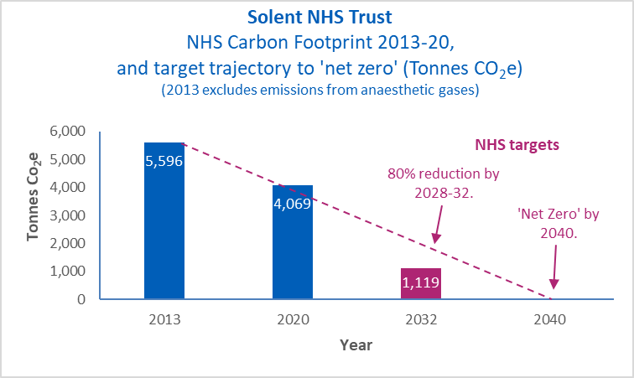

The NHS aims to be the world’s first ‘Net Zero’ national health service ([Greener NHS](https://www.england.nhs.uk/greenernhs/)) and has set the following target:

For emissions directly controlled (the **NHS Carbon Footprint**), to reach;

1. Net zero by 2040
2. An 80% reduction by 2028 to 2032.

We have adopted this target, using 2013/14 as our baseline year against which to measure and report progress, as this reflects the year Solent NHS Trust took ownership of properties across our Estate.

While significant progress has been made to date, this target is challenging. We will seek to build on reductions in emissions achieved in 2020/21 and minimise as much as is possible any ‘rebound’ in emissions post COVID-19. Progress against the target will be reported within our Annual Sustainability Report.

Changes in our carbon footprint will also be monitored relative to the gross internal floor space of our premises, as well as patient activity numbers, to ensure we understand how changes reflect real progress.

We acknowledge our Carbon Footprint will be affected by external factors such as the UK’s energy supply mix (the increase in UK renewable energy supply has, for example, significantly reduced emissions from electricity) and the ban on new diesel and petrol cars from 2030.

For the emissions that we can influence (our **NHS Carbon Footprint Plus**), the NHS has set a target to reach net zero by 2045, with an ambition to reach an 80% reduction by 2036 to 2039. We have and will set actions to influence a reduction in these emissions, where relevant.

# 

# **‘Care – for the future’**

Our Green Plan drives initiatives that focus on efficiency and deliver environmental and related social improvement in our community.

How we deliver high-quality healthcare, manage our estate, procure and use our supplies and how we travel, afford us opportunities to:

* **Transition to ‘Net Zero’** carbon emissions, enshrined in our legal obligations within the UK Climate Change Act and NHS targets.
* **Spend public money wisely** by being efficient in the use of finite resources and avoiding waste.
* **Improve local air quality**.
* I**mprove the health and wellbeing** of our people and local communities
* **Plan for the impacts of climate change** and adapt to improve the resilience of our services and estate.

As well as meeting NHS requirements as set out in the [NHS Long Term Plan](https://www.longtermplan.nhs.uk/), [NHS Standard Contract](https://www.england.nhs.uk/publication/nhs-standard-contract-service-conditions-full-length/), the [Greener NHS](https://www.england.nhs.uk/greenernhs/a-net-zero-nhs/) programme and national policy and legislation, our Green Plan supports delivery of the [UN Sustainable Development Goals](https://sdgs.un.org/goals). We are aligned with the aims of our partners in the [Hampshire and Isle of Wight Integrated Care System](https://hiowhealthandcare.org/), other NHS Trusts and public bodies, community groups and our suppliers.

# **‘SMART’ Actions**

In order to meet our carbon reduction, air pollution and waste targets, our plan is supported by a comprehensive set of initial SMART and dynamic actions, captured within a separate ‘Green Action Plan’, which will be updated every year.

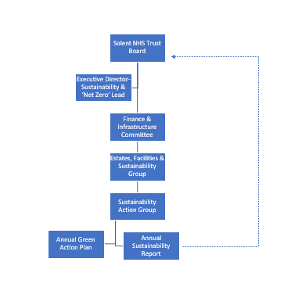

# **Management of the integrated Green Plan**

We have an Executive lead for Sustainability and ‘Net Zero’, but recognise we must take a ‘whole Trust’ integrated approach to our Green Plan. We need to consider how the decisions we make will affect our environmental impact, how we should capture data and learn from good practice. We have therefore established a Sustainability Action Group to plan and deliver our Green Plan, monitor and report on progress against our targets and actions within the mandatory Annual Sustainability Report.

# **Our Care**

**Executive sponsor: Chief Medical Officer**

Reduce our environmental impact by improving the way we deliver care and manage medicines.

**What we know**

Historically, care rightly focused on patient outcomes but didn’t always account for and consider environmental impacts.

There are opportunities to be more efficient in the management of medicines and anaesthetic gases. The use of anaesthetic gases has a significant environmental impact. The carbon footprint of anaesthetic gases used in 2020/21 is, for example:

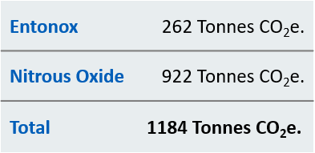

**What we have done**

When we design and deliver care, we endeavour to optimise the location of care, to facilitate earlier and faster diagnosis, reducing unnecessary treatments and delivering best clinical practice.

The Covid-19 pandemic has accelerated our deployment of telephone and online consultation technology, alongside more online appointment booking and home testing services.

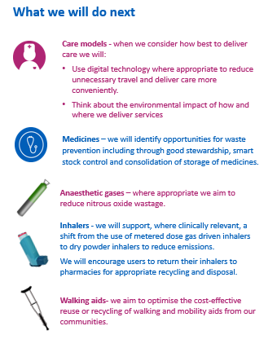

# **Our Estate**

**Executive sponsor: Director of Estates**

Reduce carbon emissions from buildings and facilities and adapt our estate to the effects of climate change.

**What we know**

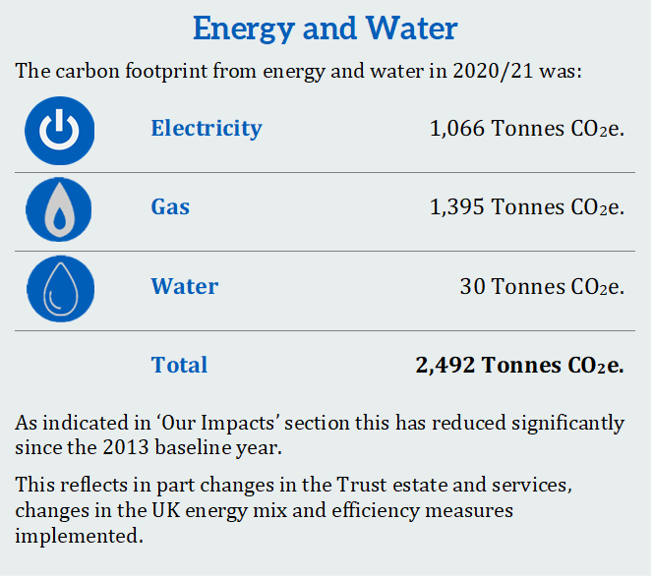Our buildings and facilities represent a significant source of our carbon emissions. Known and anticipated changes in climate will impact on our estate so we will need to plan for such changes.

In addition, indicative emissions in 2020/21, from waste treatment, based on waste quantities, are **9 Tonnes CO2e**. Waste arises from the use and disposal of products, materials and equipment procured by us and our suppliers. This includes clinical, nursing, buildings, pharmacy and others. All waste represents a loss of financial and resource value. Reducing the financial and environmental impact of waste means identifying the source of the waste and what interventions are feasible, in collaboration with relevant teams and our contractors.

**What we have done**

Undertaken a range of improvements to the Estate, including the refurbishment of St Mary’s Community Health Campus - enabling significant improvements energy efficiency including reduced emission rates of Block B and C by 45%.

Installed LED lighting across much of our estate - reducing costs and emissions.

Committed to 100% green energy supply in 2021/22.

Introduced degree day data to ensure economic efficiencies and to track consumption of our utilities usage.

Introduced 500 additional dry mixed recycling bins and improved segregation, helping to **reach our target of zero waste to landfill** (it is recycled or sent to energy recovery facilities, or in the case of clinical waste alternative treatment facilities and high temperature incinerators).

Enabled the reuse of 20 tonnes of otherwise redundant furniture by local charities, in conjunction with our waste contractor.

* Standardised design fittings as set out in our Accommodation Guide, such as light fittings.

**What we continue to do**

We work closely with our facilities providers to minimise environmental impact of their services and collaboration with contractors, including creating opportunities for local jobs and skills development. This is monitored through regular contract review meetings.

We regularly discuss the opportunities to consolidate our Estates with partners in the NHS, local authority and others.

We assess and seek to mitigate short-term risks from extreme weather events and climate change, including premises resilience planning, with the aim to also consider the effects on services of a changing climate on the most vulnerable within our communities, in conjunction with local partners, such as the [Hampshire and Isle of Wight Local Resilience Forum](https://www.hants.gov.uk/community/localresilienceforum).

We have a Nutrition Group which aims to ensure all food is healthy and locally sourced, our standard operating procedures ensure that all of our food provided meets the relevant NHS nutrition guidance. We aim to source even more food locally through our catering suppliers.

Collaboration continues regarding facilities management sustainability with the [Hospital Caterers Association](http://www.hospitalcaterers.org/) (HCA), [Health Estates and Facilities Management Association](https://www.hefma.co.uk/) (HEFMA), [WRAP](https://wrap.org.uk/) and local sustainability groups.

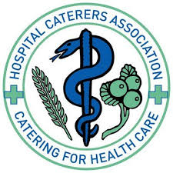

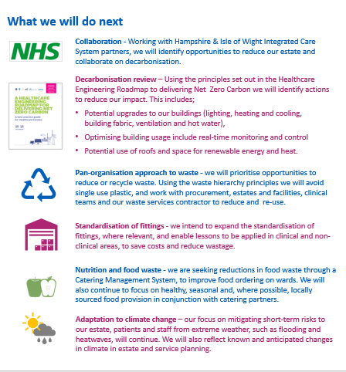

**Our Supplies**

**Executive sponsor: Director of Strategy**

We will work with suppliers to reduce emissions and deliver more social value e.g. prioritise procurement requirements according to relevant emission reduction.

**What we know**

Our expenditure on the procurement and supply of goods and services accounts for a significant quantity of carbon emissions; those that impact on our carbon footprint as well as those within supply chains.

The indicative carbon emissions, based on expenditure, arising from the procurement of goods, services and drugs in 2020/21 was **14,878 Tonnes Co2e.** Major contributors to this include buildings related procurement and office equipment. While this is an estimate only, it does highlight the importance of reducing, where possible, carbon emissions in the supply of goods and services.

The Future Operating Model for NHS Procurement, focusing on enhancing procurement efficiency and economies of scale, means that the majority of our procurement is through [NHS Supply Chain](https://www.supplychain.nhs.uk/).

**What we have done**

Our procurement policy includes requirements that all procurements should include relevant sustainability requirements to ensure the Trust is contributing to environmental targets.

Sustainable procurement principles must be considered in commercialdecisions based on whole life costs and value for money.

We support Supply Chain’s efforts to reduce emissions in conjunction with suppliers, while also seeking reduction from those who supply directly to us.

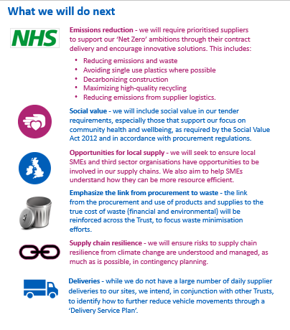

# **Our Travel**

**Executive sponsor: Director of Estates**

Reduce environmental impact through how we deliver care, travel to work and in our day to day lives.

**What we know**

Our community healthcare requires essential travel. This involves significant costs and carbon emissions. We need to be smarter in the use of travel, while continuing to provide high quality healthcare.

In 2020/21 our business travel Carbon Footprint was **384 Tonnes CO2e,** thisreduced by 35% in 2020/21 relative to 2019/20, partly as a result of greater use of digital care pathways during COVID-19.

Travel from staff commuting, patient and visitor travel and travel by contractors. currently results in emissions that contribute to climate change and poor air quality (NOx and PM2.5 pollution), impacting our local community on a daily basis.

**What we have done**

**Business travel -** our leased vehicles are low emission. We have introduced a business travel Car Club at our St Mary’s Community Health Campus.

**Commuting** - we have promoted active travel, including through the provision of new secure bike sheds, active travel events, the cycle to work scheme, exploring new methods such as e-cargo electric bikes and a shared bike servicing scheme with other local Trusts. We are also trialling the safe use of e-scooters in conjunction with local authorities.

**Couriers** - our shared-service non-patient transport courier, which undertakes over 800,000 miles every year, has changed routes to reduce the miles and therefore emissions from blood samples collection and delivery.

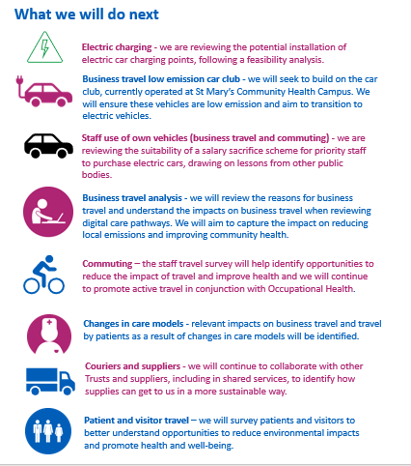

# **Our Communities and People**

**Executive sponsor: Chief People Officer**

Enable staff to adopt sustainable practices at work and home, by developing our people and clinical leaders to understand their role in our Green Plan.

Involve community representatives in the delivery, review and update of this plan and enable communities to apply lessons, improving health and well-being and reducing health inequalities.

**What we know**

To reach net zero all staff in Solent NHS Trust have a vital role to play in our Green Plan. Measures that improve our care, save money, and reduce our emissions also offer lessons and opportunities within our communities and in our day-to-day activities.

We also know that collaboration with strategic partners is essential if our ambitions are to be achieved.

Our environmental impact has a clear link to the health of our community e.g. children and the vulnerable who experience the impact of poor air quality. ‘[Alongside Communities](http://www.southampton.gov.uk/modernGov/documents/s48424/Alongside%20Communities%20-%20final%20September%202020.pdf)’ – the Solent approach to Engagement and Inclusion, outlines our overall aim to *‘keep more people healthy, safe and independent at or close to home’.* Our Green Plan is just one of the ways that we will do this.

**What we have done**

Past campaigns have raised awareness and delivered environmental improvement such as preventing 100% of our waste going to landfill, increasing waste recycling and reducing energy consumption.

We know that **investing in this area of our plan has the biggest potential to deliver the most benefit to our people and our communities.**

