**Community Celebration Event Speaker Biographies**

Caraway – Ros Simpson and Loretta Carr

Caraway is a new charity established in 2018 for the spiritual resourcing of older people in Southampton.

Chair of Trustees of Caraway is Dr Ros Simpson, retired GP and medical teacher, who works with Rev Canon Dr Erica Roberts and Lo Cuoghi in a team to arrange volunteers to do wellbeing calls to carers of someone living with dementia.

We have supported the Admiral Nurses by hosting the memory cafes across the city and now host 5 a month.

Ros says, " We are just starting to understand what a dementia community in the city of Southampton might look like, and are really pleased as a charity to link up the volunteers and resources from Southampton Churches to the needs of the families living with dementia."

Lo Cuoghi is the volunteer’s coordinator for Caraway who works matching volunteers with carers of someone with dementia. She has extensive experience of publicity and communications and works part time amongst the needs of her busy family.

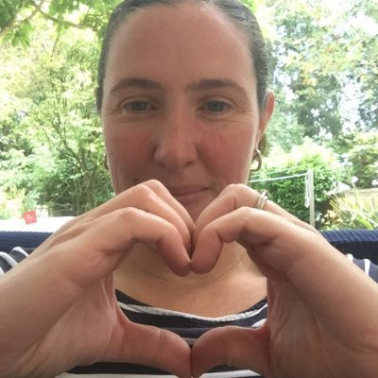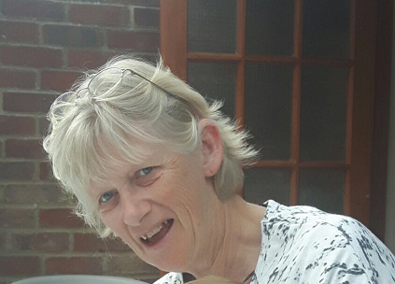

Chat over Chai – Sandra Hall, Lucky Choudhary and Mala Patel

Chat over chai is a unique Independent committee led group based in Portsmouth.

We started in 2015 but have only been Independent for about 3 years. We are unique in that we come from different faiths and backgrounds, but our common purpose is through friendship over a cup of tea and to chat.

Our aim is to offer physical, mental, and emotional wellbeing support while trying to reduce the risk of isolation. We do this through our practical weekly and monthly meetings. We offer fun craft sessions, talks on health and well-being, and projects with the National museum of the Royal Navy. Over the last two years we have done the ‘Chatterbox' project with architecture students from Portsmouth university, a Saree project and a Cookbook project. These projects help to inspire our community and give us a sense of belonging in the City of Portsmouth.

Chat Over Chai is evolving organically through our partnership with NHS Solent this last year. We are now able to offer not only a weekly group but a monthly diabetes support group as well. We specially realised the importance of reaching out to the South Asian community as there is a high risk of this disease.

As a result of our partnership with NHS Solent we have offered training in First Aid with the WEA and online Food Safety course to 10 of our members. We are also running regular Badminton and Tai Chi classes since December.

Healthy eating and training are also being offered to our diabetic members. The last years with COVID restrictions have seriously impacted our members' emotional and mental wellbeing. The support and friendship we have been able to offer has been a great encouragement to keep going during this difficult time

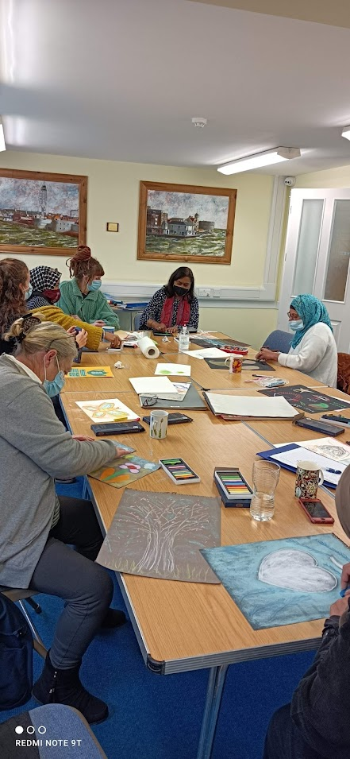 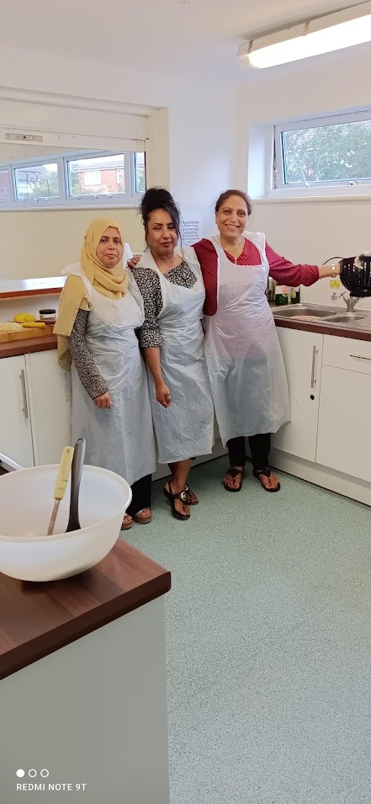 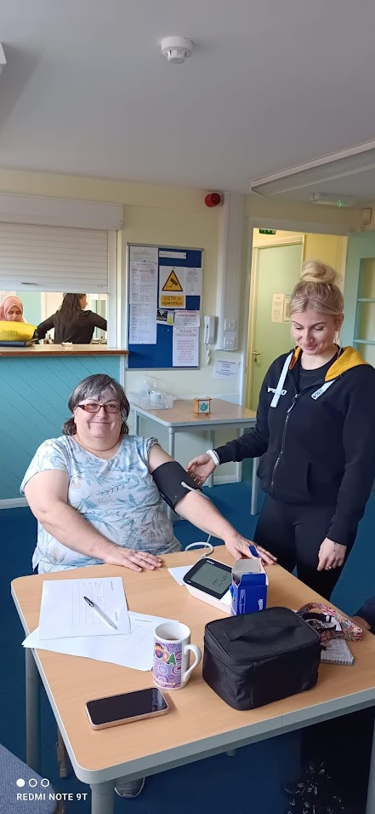

Busy People – Lorna and Dreu

|  |  |
| --- | --- |
|  | |
|  | Hello from Busy People |
|  | We are a group of self-advocates who have a learning disability and live in Southampton. |
|  | We have group meetings every Monday.  In these meetings we talk about things that are important to people with learning disabilities. |
|  | Our views also feed into the Southampton Learning Disability Partnership Board.  This means we have a voice in what the Council does, and the decisions it makes. |
|  | We work with different people and groups. We help improve their services for people with a learning disability.  An important part of our work is helping to make information easier to understand for people in our local community.  We joined Solent Trust as a Community Partner last year. We have enjoyed helping with their information. |

Carers in Southampton is a service fully funded by the local authority in partnership with the NHS.

They offer Information, signposting, carers cards, statutory carers assessments and emergency plans.

Any adult providing care and support to an adult (18 years +) who is living in the local area served by Southampton City Council and who is disabled, ill or elderly can access carers assessments, carers cards, emergency plans and link workers.  Carers cards, emergency plans and link workers are also available to carers of children and to young carers

Joseph Jenness is the Senior Coordinator for Carers in Southampton. Carers in Southampton provide support to unpaid carers who look after someone living in the city. They provide Carers Assessments, Carer Cards, signposting and support and emergency plans. Joseph joined Carers in Southampton in 2018, following a varied carer spent in foster care (local authority and private), higher education and retail. He began collaborating with Solent NHS in 2019 and is delighted by the links and networks it has helped him to establish.

In his spare time Joe enjoys spending time with his child and partner, running, and watching boxsets.

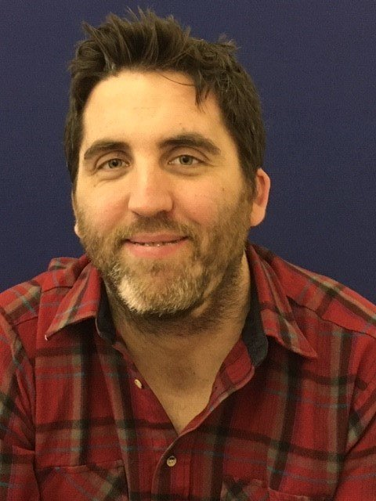

Southampton Carers – Joseph Jenness

Sindija

We are Drop the Mask Productions, an imperfectly perfect solution to your business’ IT and media needs.

Founded in 2019 on the bedrock of inclusion and authenticity, we are on a mission to break barriers and make employment and technology accessible for all.

Every day, we continue to grow whilst challenging the misconception that you must pretend to be something you’re not in order to be successful in work and life.

Now, we want to support other passionate voluntary and not-for-profit companies to find simple solutions to their IT and media, whilst supporting others to be their true selves in the workplace.

From creating a fresh new website, to capturing authentic photography or videography to match, you’re not on your own and we’re here to help you.

Greg says ‘I had a drive to make sure I was able to help others with severe mental health break barriers in finding employment, I decided to create my own employment and set up my own company – Drop the Mask Productions CIC.

Not only did I want to create something he could be proud of, but it was also about providing a place where people could thrive, regardless of their past or conditions.

Fast forward three years and here we are now in 2022, a team of 10 incredible individuals, each with their own story of turning their struggles into their superpowers’.

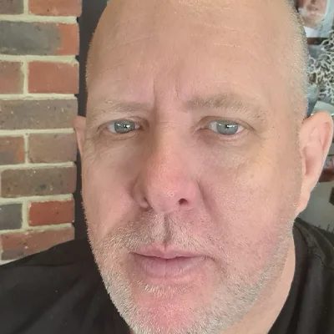

Drop the Mask – Greg White

Sindija

Solent NHS Trust Academy – Carl Adams

Sindija

I am Head of People Participation and my role is to work across the Trust to promote, support and develop working alongside patients, carers, people, charities and community groups for research and improvement. The aim is to get all services to work with their patients and community to help improve the patient care.

I love the variety of my job and working with patients, services and our community to improve the health and well-being of people. I gain enjoyment from experiencing the development, successes and learning from working with patients, people, staff and services.

