ESCAPE PAIN INFORMATION LEAFLET

What is ESCAPE-pain?
Enabling Self-management and Coping with Arthritic Pain through Exercise.
A group rehabilitation programme for chronic hip and knee pain integrating:
Patient information and education and Personalised Exercise regimen.

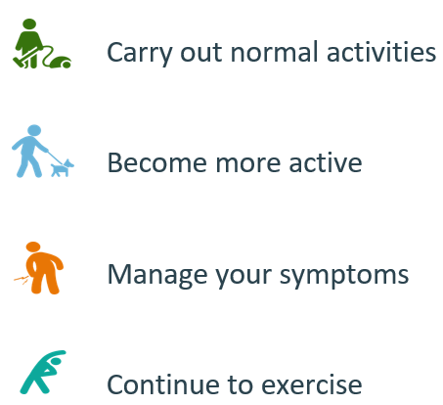
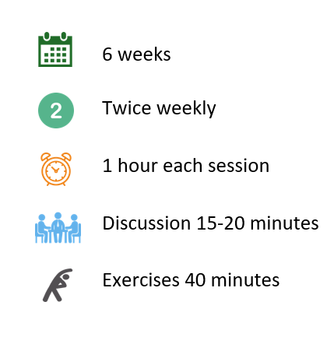
What does it involve? Aims of the programme:

WHEN AND WHERE?
- Mon 15.00-16.00 and Thurs 13.30-14.30 at Mountbatten Leisure Centre
- Cost and payment: lump sump of £45 for 12 sessions (works out at £3.75 for 1 hour session)
- £30 if they are already a BHLive member (works out at £2.50 per 1 hour session)
- ESCAPE-pain Online provide users with a structured education and exercise programme of 12 sessions over six weeks. There are two compulsory sessions per week and they are a combination of education and exercise.

How do I access this?
You can be referred to the course through a healthcare provider i.e. your physiotherapist or GP

What to wear?
- Comfortable clothing you are happy to complete exercise in
- Supportive footwear i.e. Trainers or plimsoles
- Any hearing aids or glasses (reading or distance)

If you would like to speak to your physiotherapist about actioning the referral, please call:
0300 123 6682

If you would like to speak to somebody about ESCAPE Pain from Mountbatten centre, please call:
023 9320 0401

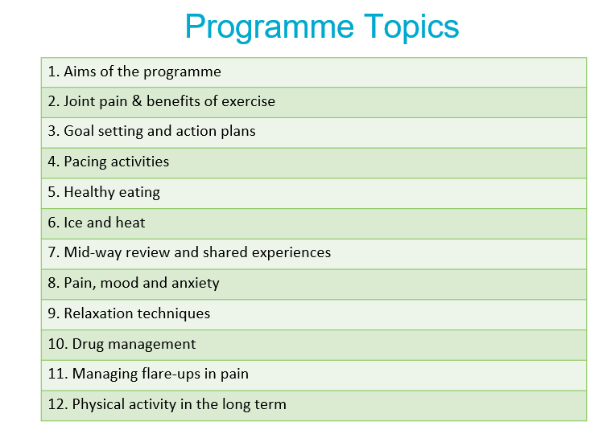

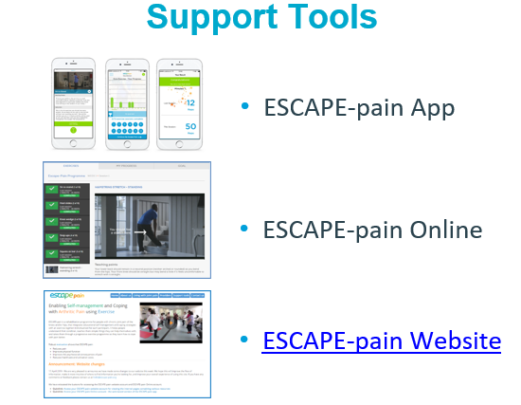
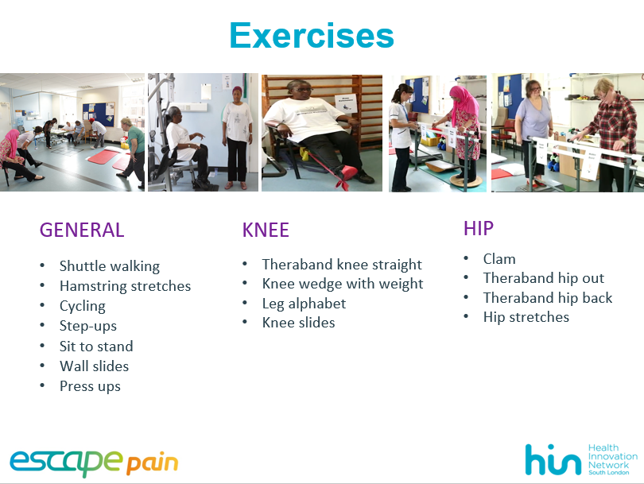

Research evidence shows that ESCAPE-pain:
- Reduces pain
- Improves physical function
- Improves mental wellbeing
- Creates benefits that can last for up to 30 months
- Reduces healthcare and utilisation costs

