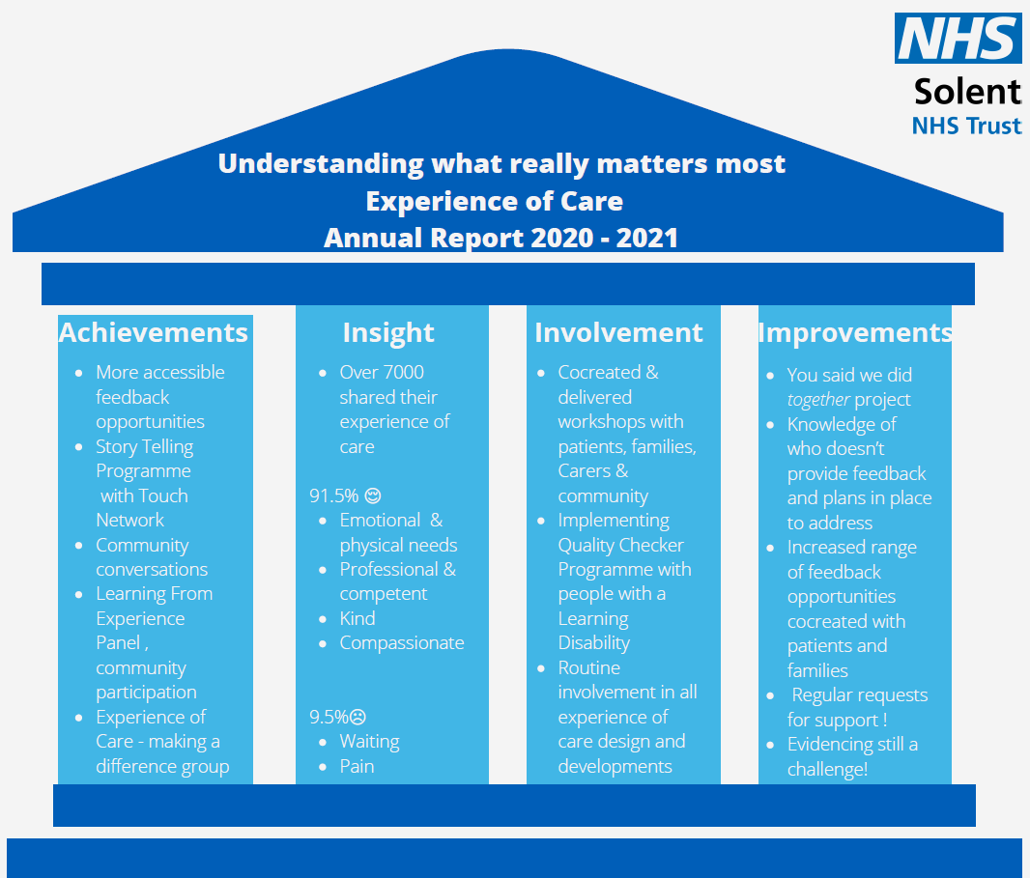

Experience of Care Partnership Ambition

“We hope to create a culture where everyone is encouraged and empowered to provide feedback, in diverse ways, on their experience of care. We aim to support services lines to strive towards achieving excellence through quality care and patient safety. We are dedicated in our ambitions to ensure that the people we serve receive the highest standards of care.”

Sarah Balchin, Associate Director – Community Engagement and Experience
Ophelia Matthias – Experience of Care Lead
June 2021

Introduction
Understanding what really matters to people who use our services, their families and carers, about their local community and mental health services is important to us. We have all, people who use services and those who provide them, experienced some of the most testing moments we will face in our lifetimes over the last year. We have seen the best of the NHS, with individuals and teams responding in a way that we could never have imagined, and the worst of the impact COVID has had on people and services. We have also been privileged to see, hear and feel how local communities have been able to gather their strengths and rally to support people, and to support us in the NHS. As we move towards what is being described as the new normal, we reflect on our learning over the last year about people’s experience of care; what we did well and what we could and should do better in the future.
This annual report provides a summary of:
- Our ambitions and achievements 2020 – 2021.
- The impact of COVID.
- Insight - what people have told us about their experience of care, who has shared that experience (and importantly who hasn’t) and how they provided that feedback.
- Involvement- how we actively encouraged and enabled people to share their story, how we have developed our approach to people who use our services in participating in experience of care developments
- Improvements – what people told us we could and should do better, what we did and what we need to do in the future.
- And provides recommendations for 2021 - 22

Our ambitions and achievements 2020- 2021
In July 2020 we agreed three key objectives, and a number of supporting projects; all based on what our patients, families and carers had told us is important to them. Whilst the pandemic has impacted on the scope and scale of implementation of our objectives, we have still made significant progress in developing a better understanding of what matters most to people who use our services, and working them, continue to strive to deliver that positive experience of care.
Objective 1 | Objective 2 | Objective 3
Come to us – your patients: we shall provide a broader and more creative range of face to face feedback opportunities with a focus on people we seldom hear. | Hear our story – and that of our families and carers: we shall develop the concept of community conversations, increasing the number and scope to enable more people to have their say. | Do something with what we tell you - and tell us about what you have changed: we shall implement a system of recording and reporting what services have done with the gift of feedback from people who use our services.
We have:  - Introduced virtual face to face feedback opportunities, including joining community group meetings, 1:1 conversation with patients, families and carers, and facilitating community conversations.  - More effectively used social media platforms to connect with individuals and groups, and used a “snowball” approach to extending our reach with every conversation we have.  - Cocreated and commenced the Story Telling Champions Programme; a programme to equip service line and corporate team members and our community partners, with the skills to gather and tell stories to facilitate improvement in experience of care. | We have:  - Effectively used community conversations during the pandemic to better understand the impact of COVID on individuals and groups, identifying areas of great practice as well as things we need to improve.  - Developed and implemented guidance to support any person who is interested in facilitating community conversations.  - Used the concept of community conversations to further our reach to groups we seldom hear.  - Supported individuals and service line teams in the use of the principles of community conversations to enable feedback. | We have:  - Introduced to the Learning from Experience Panel an opportunity for teams to share what they have done in response to an expression of concern, and the impact of that action.  - Started to introduce more robust systems of recording actions and outcomes.  - Recognised this as our greatest challenge and sought support from community partners to develop our understanding of how we could do this better, which has informed our priorities for action for the next year,
Supporting projects

National Complaints Standards Framework – support the inclusion of local people in the development of the framework, and as part of the national working party advise on improving access to the complaints process.

We have:
- Facilitated a workshop with the PHSO national development team, enabling local people( patients, community partners and Solent team members) to have a voice in the development of the national complaints standard framework.
- Contributed to the development of the framework by sharing our approach to promoting access.
- Been chosen to be an early adopter of the framework from June 2021.

Experience of Care Pathways – lead the development of a system wide, local people, health, social care and third sector partnered approach to gathering and using feedback to improve the services we provide.

We have:
- Facilitated a virtual, whole system event - “Tell your story” - with community partners, community groups, individuals and colleagues from other health and social care providers in November 2002, the aim being to understand what we do well and what we need to change in to better understand people’s pathway of experience across the whole system of health, social and voluntary services care.
- Identified and agreed three priorities for action:
  - Further expansion of feedback opportunities across the whole pathway, with a focus on those we seldom hear.
  - Developing and implementing ways of sharing experience of care – both positive and those for improvement, across providers to encourage the removal of the artificial barriers that are in place for patients and families.
  - Supporting teams and individuals to receive feedback about poor experience of care, to enable positive and action orientated responses whilst helping individuals contend with what can be very challenging information.
- Agreed to expand the scope of the service user led measures group to be the Experience of Care – making a difference group, providing oversight to the delivery of the experience of care improvement work programme.

An integrated approach to experience of care and patient safety – pilot a new Experience of Care Lead role to improve our collection and use of experience of care data alongside safety and quality data, ensuring a more holistic approach to quality monitoring to drive quality improvement.
We have:
- Piloted and evaluated the impact of the role and recruited to substantively.
Supporting family carers – working with Portsmouth Hospitals, NHS Trust, the Carers Centre Portsmouth and Adult Social Care pilot a way to improve early identification of carers and improve our understanding of the experience of carers.

We have:
- Completed the discovery programme with Portsmouth Carers.
- Expanded the scope to include all carers, no matter their area of residence.
- Agreed two key priorities:
  - Continue to improve the early identification and signposting of current and new carers to support services in all areas we serve.
  - Helping members of team Solent who are family carers remain in work.
- Secured ongoing support from the Portsmouth and Southampton Carers Centres and the Solent People and OD Team.
- Been asked to support Portsmouth Hospitals University Trust new carers lead as a joint programme of work.
Involving local people in everything we do – simply making this the way we do things here at Solent!

We have:
- Increased (and continue to at about 5 new groups per month currently) the membership of our community partners programme, which provides the foundation of a resource of people from the local community to support us.
- Started to develop a People Participation Framework with community partners and members of Solent teams, to provide guidance for the safe and effective approaches to enable people to be involved.
- Increased our patient, family, carer and community membership on the Learning from Experience Panel, the ultimate aim being this group will be community led.
- When planning developments, the community engagement and experience team actively consider who in our local community can support e.g. local graphic designers rather than NHS design, local CIC for training and development rather than national teams.

Impact of COVID
The national policy on collection of experience of care feedback and responding to complaints was significantly changed in response to the pandemic. The national Friend and Family Test (FFT) programme was suspended until January 2021, the national experience of care survey programme was also suspended, and the national complaints guidance advised organisations to accept and respond to only those complaints considered to be serious. Face to face meetings with people who wished to express a concern were no longer possible.
Locally however, we decided to continue to offer feedback opportunities in the form of FFT and I statement surveys, recognising that there would less focus of clinical teams in promoting collection, and there would be a resulting reduced response rate. We also continued to develop our approach to community conversations, enabling the collection of a rich narrative about people’s experiences during the pandemic. Service line teams were offered the option to suspend investigations and responses to appropriate complaints to release time for clinical teams to provide essential services, but this offer was in the main declined and service lines continued, completed and reported complaint investigations. It is noted that there have been in recent months there has been an increase in the number of people who have asked for their complaint investigation to be re-opened (see p x for further information).
Between April 2020 and March 2021 the services we provide were affected by the need to focus on services essential to support a timely response to the pandemic. With team members redeployed and capacity in supporting services reduced, it needs to be acknowledged that the experience of care of many people who used our services would not be of the standard we would usually expect. The limited amount of insight we have from established feedback opportunities has been supplemented by community conversations, links with community groups and increased representation on groups and committees of people from our local community. What we do know is that we have a developing concern of, albeit expected, waiting times, and we shall endeavour to better understand what we can do to reduce the impact of people’s quality of life from that wait.

It is usual in an annual report, to provide previous years results as a comparison. In the light of the significant impact of changes in national guidance, neither benchmarking nor comparator data is provided. We have endeavoured to interpret the data collected in the context of the pandemic and have used what we have learned to provide a foundation for the priorities for the coming year.

Insight – what have we learned about people’s experience of care?
Over 7300 people provided us with the gift of feedback between April 2020 and March 2021.
91.5% shared their story of a positive experience of care. They told us about having their emotional and physical support needs met, being cared for by staff who were competent and professional, teams who were helpful, compassionate, and friendly.
“I felt female consolidation – you took that feeling of helplessness and gave me back control.”
Sexual Health Services.
9.5% however shared a poor experience. Complaints about care and treatment accounted for 1.5 %of feedback (see App 1) ; contacts with PALS for support to resolve a concern quickly and directly with the service 5.1%, and 2.5% used FFT/I Statement survey to express their view of poor care or service. The key areas of concern reported include clinical care and treatment, communication, and attitude of staff. These are the three issues most frequently and persistently raised in the NHS.
“Managed to make my child feel comfortable enough to open up and speak about things. “
CAMHS Portsmouth

“My daughter is getting bigger and the car parking spaces are very tight and often very far away from the centre. There isn’t a safe place to open up a pram so we carry her as she is unable to walk. Often the disabled bays are free and very close to the centre but we don’t have a disabled badge. Parent/ child bays would be very useful and reduce the worry of not finding a space close by.”
Childrens Services
“I felt I wasn’t treated like an adult.”
Mental Health Services

Who provided feedback?
Our ambition is to develop a better understanding of the experience of care of all people who use ours services, and to achieve that we need to know who currently provides feedback and most importantly who does not. The current data set is limited (see App 2 ) and will be further developed over the next year in accordance with the standards being set for our community engagement programme, but does tell us two key things:
- People who use our feedback systems provide a limited amount of the demographic details we request; we need to understand why and how we can improve that and ensure people know why this information is important to us.
- There is a disproportionately low number of people with al earning disability providing feedback; whilst this is in line with figures nationally, we are not happy to accept that as a provider of specialist LD services.

Friends and Family Test (FFT)
The FFT survey is a national programme which aims to provide every patient with the opportunity to share their feedback about experience of care. We now provide three options. SMS text messaging, paper survey and web based online feedback. The text option was introduced in January and so far has proven very popular with about 40% of the total number of FFT responses being provided by text in the last 3 months of the year.
Over 6000 people shared their feedback using FFT (see Fig 1). The majority (5873) reported a positive experience of care. 155 however, reported their experience as poor or very poor. FFT is anonymous and not everyone provides comments to support their feedback score, whether positive or negative. Key themes can be identified from the comments provided.
Figure 1- Friends and Family Test Results
People told us about their most positive experiences. They told us:
Their emotional and physical needs were met
They were cared for by professional and competent staff
People were helpful
People were compassionate.
And what we could do better:
Waiting – waiting for appointments, waiting for people
Pain relief and management
There is a developing concern about waiting times, albeit expected as we reintroduce services. The important of communicating effectively with people who are waiting cannot be overestimated. The Experience of Care Team are commencing a programme of work to explore with people how we may best keep them informed and also to better understand the impact of waiting on their quality of life. A deeper review of the reports of poor pain management is planned.
Patient Advice and Liaison Service (PALS) and Complaints
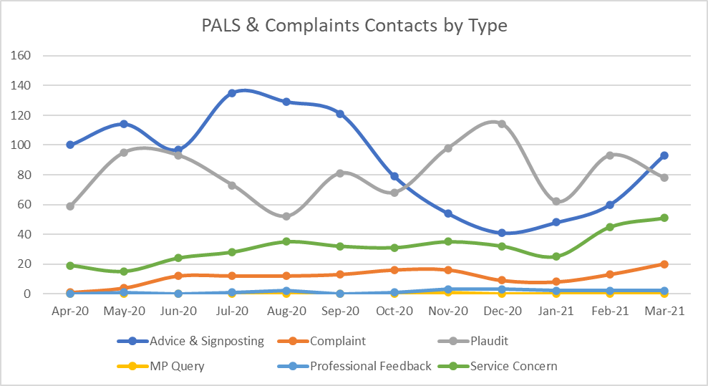
PALS provide support to people who use our service, their families and carers and act as a contact point for professionals from other organisations and Members of Parliament who wish to raise an issue. They offer advice and signposting to people who call, which can include information about services, accepting unsolicited plaudits about someone’s care and treatment, responding to an expression of concern for which a quick resolution is requested, and they can be the first point of contact for someone who needs to make complaint. Activity and the reason for making contact varies (Fig 1), with the predominant activities related to advice and signposting and receiving plaudits. A review of the specific purpose of contact has identified a lack of easily accessible information at service line level and on the Trust communication platforms.
Figure 2 - PALS and Complaints - reason for contact
Outcomes of complaints
There are 5 types of outcomes reported: not applicable indicates the formal complaint has been withdrawn; not upheld, there has been no case found on investigation; partially upheld is when some elements of the complaint are established as a true representation of the care; upheld, all elements and ongoing, indicates the complaint is still under investigation. Each complaint receives a
Outcome | Number
N/A | 4
Not Upheld | 24
Partially Upheld | 54
Upheld | 46
Ongoing | 9
formal response and work is in progress to significantly improve our understanding of the actions taken in response to a complaint and the impact of that action. Whilst 24 of the 137 complaints raised were not upheld, it remains important to understand why people felt a need to raise a concern at all. This will continue to be an area for improvement.
Parliamentary Health Service Ombudsman (PHSO
The PHSO makes final decisions about complaints that are made about care and treatment in the NHS, which have not been able to be resolved locally. In these circumstances the person who had cause to raise a concern may ask the PHSO to review their concern and the process the NHS provider followed to in the endeavour to respond to and resolve the issue.
Between April 2020 and March 2021, 1 person who had previously raised a complaint about one of our services asked the PHSO to review their case. After a preliminary assessment, where we provided the information requested by the PHSO, we were advised that no further action was required. It is important to note however, that for someone to need to escalate their concern to the PHSO means that at some stage we are likely to have not done everything we could to resolve their issues. The need for people to escalate a concern to the PHSO will be a focus for improvement in addition to those complaints not upheld.
Reopened complaints
Reopened complaint investigations are when a final response has been provided to a person who has raised a concern, but the response does not meet their needs. This may be due to questions remaining unanswered, challenges to the information we provide and/or requests for meetings to discuss further but not matter the reason for the request, this is an area of concern. There has been a two -old increase in reopened complaints (from 14 to 28) in comparison to 2019-20. Whilst as previously noted it is important to not directly benchmark data year on year due to the significant differences in guidance and operational changes, it is important for us to understand all requests to reopen complaints. This will be combined with the work to understand “not upheld” complaints and PHSO referrals.
Involvement
The active involvement of patients, families, carers and people from our local community is a principle that underpins everything we do. Over the last year we have, for example:
- Increased the number of range of representatives from the community on the Learning from Experience Panel, a sub group of the Quality Improvement and Risk Group, the aim being for this to become user led.
- Expanded the scope of the service user led Experience of Care Measures Group to oversee and direct the work programme generated from the Tell Your Story Event in November.
- Worked with community partners to cocreate and deliver workshops and events to explore and discover what really matters most to people who use our services and secured their support for task and finish groups to undertake that work.
- Cocreated and now delivering, our Story Telling Programme with Touch Network, a group of people living with enduring mental ill health.
- Planned a Quality Checker Programme with people with a learning disability, asking their expert opinion about how we can better understand if our services meet their needs.
- Routinely ask patients, families, carers and members of our local community to review, advise and input to projects, big and small.

IMPROVEMENT
Evidencing improvement as a result of the gift the feedback, that being good or for areas we need to improve, has been the most challenging aspect of this year’s work. With the significant operational pressures on services and team members redeployment, the focus has been on keeping the people we care for and our teams, safe. We have recently however started a number of initiatives to measure actions and improvements, using a range of methods. These include.
- You said, together we did….monitoring, measuring and sharing the impact of actions from complaints in partnership with patients, families and carers. Making early contact with people who have cause to raise a concern, ensuring clarity of what they are asking for and working with them to ensure we answer those concerns in a timely, accurate and complete way.
- Learning from Experience Panel Case Studies.
- Introduction of more robust system of recording actions and outcomes from feedback.
- Story Telling Programme – to develop individuals knowledge and skills about how to effectively gather and use stories to guide improvement and evaluate the impact of change.

A Story of Improvement
“There was never a plan for any of the interventions – whether that was calls, home visits or hospitalisation.
Private services were rubbished in front of my son – these are trained professionals and my son’s psychiatrist hit a brick wall in trying to get the NHS to engage with him so he could hand over and help get him the crisis care that he recognised that my son needed.

Systems that were accessible to nurses weren’t reviewed to get a picture of what had happened previously, and it was clear notes weren’t being read. Both I and my son had to repeat ourselves so often. Having to re-live suicide attempts on numerous occasions has meant re-living those traumatic events each time.

When dis-satisfaction was expressed at services leaflets were given to us around complaints procedures – I didn’t want them – I just wanted to get my very ill son the support he needed.
In the end only a complaint to my MP resulted in any action being taken – and that was to transfer to a different team ………as all faith had been lost in the …..team.

The weight of looking after a poorly child has been almost doubled with the fight I’ve had to have to get him the support he needs to save him and help him recover. I cannot under estimate the impact it’s had on me and my mental health. As a parent I will always keep fighting for my son – but it shouldn’t be a fight, it should be easy and supportive.”

The pain this mother, her son and family experienced is clearly evidenced in her candid approach but thankfully their journey did not end there. Since this episode both the mother and her son have been well supported………... They have been listened to and plans are now in place for her son to be given the treatment he needs. The mother readily admits that although things are not perfect they are so much better.

The intervention by the ………………leaders and their offer for this mother to share her experience by allowing the Experience of Care team to film her story to train staff is powerful. The impact of affording someone the space and time to be real even if it’s painful and highlights failings in our services allows the storyteller to be authentic so that their story can then become a catalyst for change. The impact for the storyteller is cathectic and one of empowerment and the rebuilding of trust. No one would agree to be filmed and for their story to be shared if they did not trust that it would be used for good. Hopefully, the impact on our staff who see this film as part of their training will be compassion and empathy. The impact for those of us who are trusted to capture the stories of those who are sharing painful feedback is one of honor. We are honored that we are trusted to capture their gift of feedback.

Ophelia Matthias, Experience of Care Lead.

……. Some specific details have been removed.

SUMMARY
The past year has posed us many challenges but also opportunities. We have further recognised how working with patients, families, carers and our local community as true partners, affords us access to an amazing arrays of skills and knowledge, and a clear insight into what really matters most to them about their local community and mental health services.
As we return to the new normal, we wish to refresh our ambitions to better understand the experience of people who use our services, and to strive to meet, and hopefully exceed, their expectations. With that in mind the following recommendations are made based on what we have heard and learned over the last year from patients, families carers and people of our local community.
- Improve our understanding of the cause of lack of satisfaction in our management complaints, to include complaints not upheld, complaints re-opened and complains referred to the PHSO; and to make changes in practice to reduce incidence of reopened complaints and maintain or reduce the number of PHSO referrals.
- Participate in the national pilot of the PHSO Complaints Standard Framework, ensuring the active involvement of people who have had cause to raise a concern, providing honest and constructive feedback to the national team.
- Implement a demographic data set for all experience of care feedback, in line with the standards being developed with the Alongside Communities – the Solent approach to engagement and inclusion programme, to improve our understanding of which people we seldom hear.
- Fully implement the quality checker programme supported by people with a learning disability, and roll out the programme to include people from seldom heard groups to support a better understanding of people’s experience of care; increase feedback from seldom heard groups.
- Develop and implement a robust system for the sharing and celebration of best practice, enabling learning across the organisation; reducing variation in experience of care.
- Continue to expand the opportunities for people to provide feedback, seeking advice from people we seldom hear about how best to do that.
- Progress the deep dive review of concerns about communication, previously deferred to due to the pandemic.
- Undertake a review of concerns about waiting times, improving our understanding of how we may best communicate with people and how we can reduce the negative impact on quality of life.

App 1

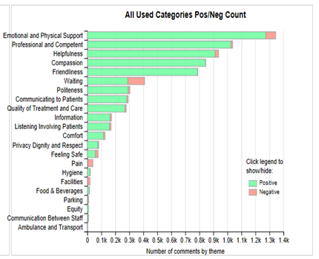
Experience of Care Feedback Themes
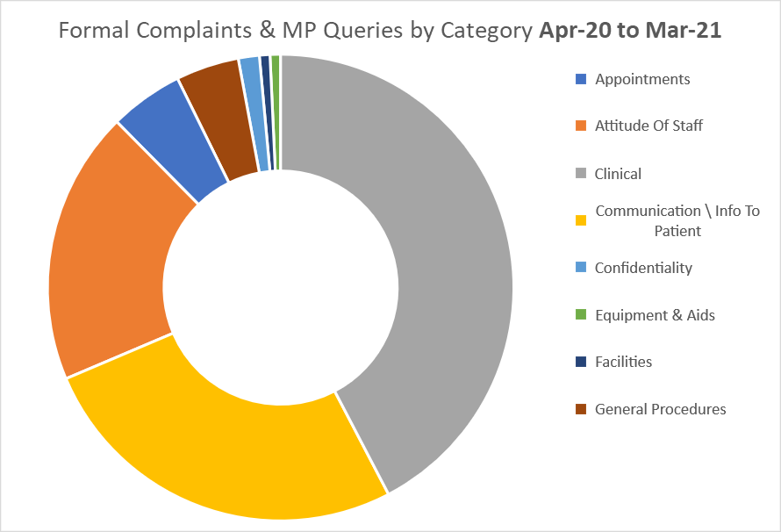

Figure 3- FFT and I Statement Survey
Figure 4 - Complaints and MP Enquiries Themes
App 2
People who provide feedback
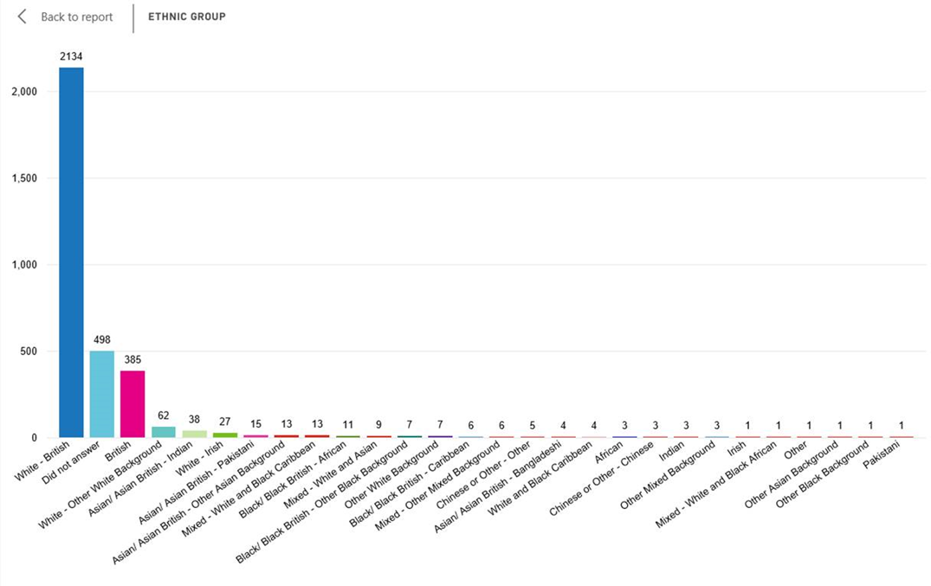
Figure 5- Ethnicity of People Providing Feedback
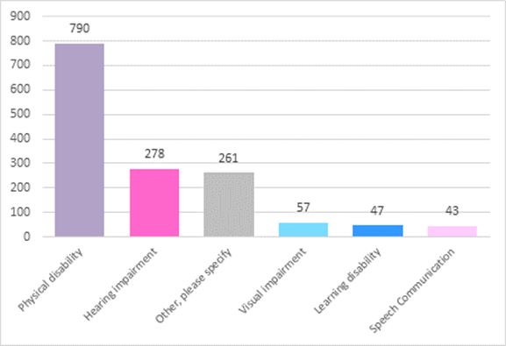

Figure 6- People with a disability

