1

Diversity & Inclusion Annual Report 2021

Authors:

Pamela Permalloo‐Bass – Associate Director Diversity & Inclusion

Kate Sonpal ‐ Head of Diversity & Inclusion

Driving Diversity & Inclusion at Solent NHS

  - Introduction

This paper provides a Diversity & Inclusion update to the Trust Board.

The Trust has a statutory obligation under the Equality Act 2010 to publish a range of monitoring information relating to patients and staff. This report is one of the ways in which the Trust fulfils its obligations.

This report provides the board with an update and progress report in relation to the EDS2 (Equality Delivery System2, NHSE workforce standards, Gender Pay Gap and contributes to meeting our PSED [Public Sector Equality Duties]). By publishing our annual data on the Trusts main functions in relation to Diversity & Inclusion we are adhering to our Public Sector Equality Duties (PSED) obligations and our moral responsibility as a health care provider and employer.

D&I Strategy

We have created a Strategy which will drive us forward in our commitment to an inclusive culture across the organisation to ensure that all members of our staff, patients, carers, volunteers, and visitors feel valued when they connect with our services.

    - We want to make it easy for our diverse communities to access our services
    - We want to recruit and retain staff from diverse communities
    - We want all our staff and those who use our services to be valued and respected as individuals
    - We want to offer and provide learning and development opportunities to our diverse workforce

Our Board and senior leadership team will support this agenda by:
    - Modelling the behaviours from our HEART values to promote a positive inclusive culture in the organisation
    - Providing the resources required to deliver on Organisational Diversity & Inclusion
    - Having oversight to ensure that our PSED (Public Sector Equality Duties) are being effectively implemented

The Associate Director of Diversity and Inclusion has a key role in:
    - Helping to raise the profile of Diversity & Inclusion internally and externally at Solent NHS Trust
    - Providing expertise and senior leadership to the Trust Board and Executives
    - Supporting senior leaders to develop inclusive cultures within their divisions

The Trust is engaged with the Diversity & Inclusion agenda and has embedded NHS England’s workforce standards and engaged with third sectors organisations, regional & national networks, to learn and share best practice. This strategy runs parallel with the Engaging Communities work.

D&I Objectives

Solent NHS Trust will make advances on all protected characteristics, in particular disability, sexual orientation, and race equality. Research shows that if we make improvements on race equality, we will make advances on all the nine protected characteristics.

Therefore, we will use the Workforce Race Equality Standard (WRES) methodology at Solent with the aim to improve on the following as part of our commitment to the 10-year WRES plan:
- Increase our talent pool of BAME staff
- Ensure there is an equitable process for BAME staff in relation to Disciplinary and Grievance
- Improve our understanding on blind‐spots in the recruitment process end to end

We aim to ensure that our community partners reflect our diverse communities in areas we work in and have been involved in creating the Alongside Communities Strategy.

We intend to improve our data collection by offering support through our learning and development team with self‐identification and refreshing data for our workforce and patients.

Delivering on Standards for Diversity & Inclusion
  - NHS Standards ‐ EDS2 Progress

The Equality Delivery System (EDS2) can be used by Trusts to ensure that they are meeting their PSED requirements. In July 2019, we reviewed our performance against the EDS2 criteria and guidance to ensure that the Trust was engaging with its service users and workforce. Plans were in place to re-visit our EDS2 again this year, however, this did not happen due to the pressures incurred by Covid‐19. The Equality and Human Rights Commission has recognised the burden of the pandemic on Trusts and has extended the reporting period for PSED to 5th October 2021. In 2022 there will be a new EDS it is currently awaiting sign off.
https://www.solent.nhs.uk/media/2019/eds2_jan‐2020‐ks‐ppb.pdf

NHSE Workforce Race Equality Standard (WRES)

Evidence shows that a motivated and inclusive workforce results in better patient care and increased patient satisfaction and safety. The Workforce Race Equality Standard (WRES) is a set of 10 indicators that

are used to measure workforce race equality and has been mandated through the NHS standard contract since 2015‐16. The metrics for indicators 1 – 4 are taken from ESR data, 5 – 8 from the NHS staff survey results and metric 9 from Trust Board.
All workforce data has been taken from the ESR records dated 1st April 2019 to 31st March 2020. This data is then fed into the WRES report for 2020. The data covers staff categorised under the Agenda for Change. Please note that the WRES team only ask for data on substantive staff. There were 3638 members of substantive staff, of which 9.2% were from a BAME background. The BAME population of Hampshire is 7% (Hampshire County Council) illustrating that our staff are representative of the populations that we serve.
There is a higher percentage of BAME staff in band 2 and 3 non‐clinical roles. As of 31st March 2021, there is currently 1 BAME staff member at 8D clinical, 2 BAME staff members at 8D non‐clinical, 1 BAME staff member at band 9 and none at VSM (Very Senior Manager).
In September 2020, 2 senior BAME leaders acted up in director/ executive roles. The updated BAME senior leader including VSM data will be reflected in our Solent WRES 2021, to be published in September 2021.

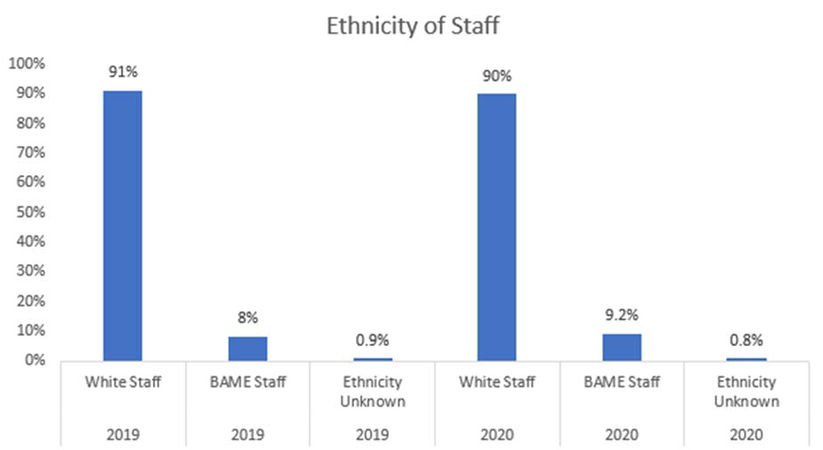

Clinical | White | BAME | Non‐  Clinical | White | BAME
Under band  1 | 0% | 0% | Under Band  1 | 0% | 0%
1 | 0.07% (3) | 0% | 1 | 0.4% (17) | 0.02% (1)
2 | 3.2% (137) | 0.62% (26) | 2 | 6.1% (255) | 0.8% (34)
3 | 7.9% (333) | 0.57% (24) | 3 | 7.5% (314) | 0.5% (19)
4 | 4.2% (177) | 0.3% (14) | 4 | 2.3% (97) | 0.1% (6)
5 | 8.3% (347) | 1.4% (59) | 5 | 2.4% (98) | 0.19% (8)
6 | 15.1% (630) | 1% (44) | 6 | 1.3% (53) | 0.1% (6)
7 | 8.6% (361) | 0.5% (21) | 7 | 1.3% (56) | 0.04% (2)
8a | 3.14% (131) | 0.16% (7) | 8a | 0.8% (35) | 0.04% (2)
8b | 1% (42) | 0.04%  (2) | 8b | 0.4% (20) | 0.04% (2)
8c | 0.2% (9) | 0.02% (1) | 8c | 0.3% (12) | 0%
8d | 0.2% (9) | 0.02% (1) | 8d | 0.3% (13) | 0.02% (1)
9 | 0.02% (1) | 0% | 9 | 0.04% (2) | 0%
VSM | 0.02% (1) | 0% | VSM | 0.04% (2) | 0%
Medical | White | BAME
Consultants | 0.84% (35) | 0.4% (20)
Of which senior medical  manager | 0% | 0%
Non consultant  career grade | 1.3% (50) | 0.04% (21)
Trainee  Grades | 0.38% (16) | 0.2% (7)
Other | 0.4% (15) | 0.1% (6)
Table 1 Breakdown of staff banding and ethnicity

Work themes in place to address these issues include:

- Pilot Group Coaching Session for staff with protected characteristics (in partnership with Hennessy Coaching)
- NHS Leadership Academy’s Reciprocal Mentorship for Inclusion Programme underway
- Sharing job opportunities with Community Partners
- Deep Dive into our recruitment practices
- The Big Conversation
- Working with specific workstreams across HIOW ICS (Hampshire Isle of Wight Integrated Care System) focusing on recruitment, retention, and talent management
- Anti‐Discrimination Taskforce

The BAME resource group is a safe space for people to share their experiences and learn from others. Ongoing promotion of Freedom to Speak Up for BAME staff continues, which enable staff the opportunity to raise concerns in a confidential and safe environment.
The 2020 staff survey showed an increase of 4.3% of staff who had experienced discrimination at work from a manager/team leader or other colleague. These figures will be included in the 2021 WRES report, but a targeted action plan focusing on the three service areas which reported the highest levels of discrimination is already in place because of these figures. This work and any learning will be included in the WRES action plan 2021 and further discussed at the Workforce and Organisational Development Committee throughout the year.

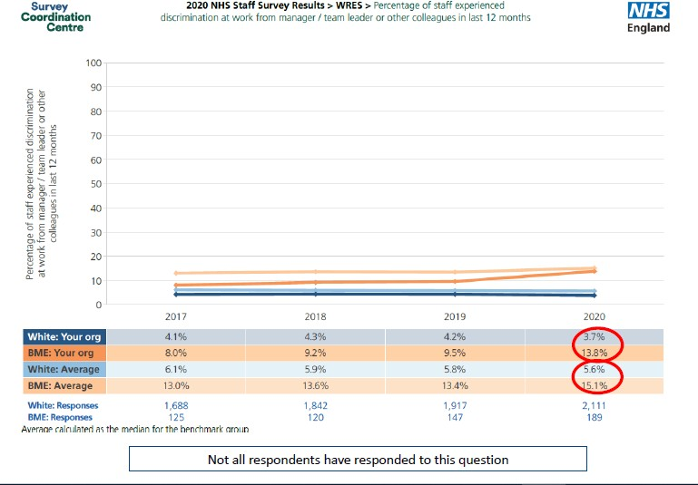

Diagram 1 Percentage of staff experiencing discrimination from a manager/team leader of colleague

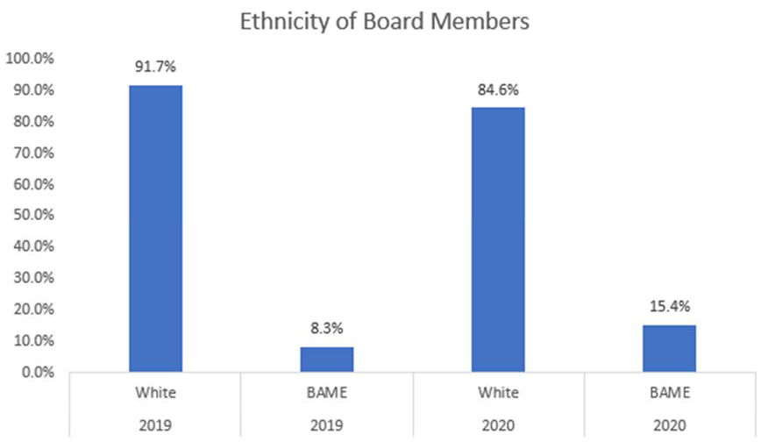

Board diversity is important to avoid group think, and it allows more nuanced discussions. Solent is proud to have its Chief People Officer and Chief Nurse as its Board level BAME Sponsor as recommended in the 5 ambitions of BAME Networks by NHS England (BAME staff networks in NHS Organisations, 2020).
SOLENT WRES FIGURES NEW‐2.pdf

NHS Workforce Disability Equality Standard (WDES)

The WDES are a set of ten specific metrics that compare the workplace experience of staff with a disability and non‐disabled staff. It allows the Trust to understand the experiences of their staff with a disability and plan to create a more inclusive work environment. As with the WRES the metrics are taken from both ESR and staff survey results.

Key findings from National Staff Survey Report and ESR data from 2019‐ 2020:

    - The likelihood of staff with a disability being appointed to a job compared to non‐disabled staff has increased from 1.56 to 1.20 showing slight progress from the previous year.

    - Solent has no reports of staff with a disability being entered into the formal disciplinary process during this reporting period.

    - Rates of bullying and harassment of staff with a disability by managers is 12.6% compared to 5.6% of non‐disabled staff; by other staff is 15.8% compared to 9.7% of non‐disabled staff, and from patients and service users 29.15% compared to 19% of non‐disabled staff. All these results are under the benchmark group median

    - Reporting of abuse for both staff with a disability and non‐disabled staff has increased from last year (59.7% of disabled staff and 62.2% of non‐disabled staff)

    - 87.7% of staff with a disability believe that Solent provides equal opportunities for career development and promotion compared to 93.1% of non‐disabled staff. This is a slight increase from last year for both groups of staff

    - 27.8% of staff with a disability feel under pressure to attend work when not well compared to 13.1% of non‐disabled staff

    - 48.3% of disabled staff were satisfied that their work was valued by the organisation compared to 59.4% of non‐disabled staff. This shows a very slight increase in dissatisfaction for disabled staff from last year (49.1%)

    - 83.3% of disabled staff felt that adequate adjustments have been made for them to be able to work which is above the national benchmark of 76.9% and an increase on last year’s figure of 79.3%

Actions that have been taken to improve the work experience of staff with a disability include:

    - Newly formed WDES Taskforce
    - Pilot Group Coaching Session for staff with protected characteristics (in partnership with Hennessy Coaching)
    - Trust accepted onto the NHS Leadership Academy’s Reciprocal Mentorship for Inclusion Programme
    - Sharing job opportunities with Community Partners
    - Deep Dive into our recruitment practices
    - The Big Conversation
    - Anti‐discrimination Taskforce
    - International Disabilities Day Conference

Gender Pay Gap 2021

In 2020 we saw an increase in our average pay gap and an improvement in our median pay gap. However, in 2021 we saw an overarching reduction in our average pay gap and an increase in our median pay gap (mid‐point) of all salaries for males and females, respectively.
Our average pay gap for 2021 is 12.87% and our median pay gap for 2021 is 2.37%. Our bonus gap was dramatically improved by the Covid‐19 arrangements for clinical excellence awards meaning all consultants received an award of equal value, regardless of contracted hours.

Solent continue to have the lowest pay gap in HIOW, based on reported figures available and are generally middle of the range of comparators for bonus pay (as all provider trusts are impacted by legacy clinical excellence award arrangements).
In total Solent has 14% male employees. This combined with men in senior roles means that it does not take much of a change in the male profile to swing or change in the percentage of the pay gap.
The final year of the 2018 – 2021 AFC “Refresh” impacted both positively and negatively the pay of some senior female and male staff, with those in mid‐range 8d and band 9 posts seeing a reduction in their hourly rate in 20/21 and those moving to the top of band 8d and 9 seeing a significant increase in 20/21. Where the “refresh” adjustment reduced the pay of some senior females and increased the pay of some of our senior males, along with the removal of band overlap in all of the bands the resultant shift impacted our Median pay gap but overall had a positive influence on our average pay gap where, for example, staff in band 7 greater proportion of women benefited most greatly from the refresh.
Legacy Clinical Excellence arrangements, which are incorporated into pay, and were traditionally paid pro‐rata for part time consultants (generally women) have an impact on consultants pay gap, reflecting 0.6% of our overall percentage pay gap.
Salary sacrifice, 90% of which is taken up by females accounts for 0.1% of the average pay gap

The next step is to agree our action plan for period 2021/22 and to monitor and report on our progress against our 2021 plan as at our next snapshot date of 31 March 2022 (requirement to report by 30 March 2023).

Sexual Orientation Standard (SOM)

The SOM provides a consistent mechanism for reporting the sexual orientation of services users aged 16 and over. However, it is not mandatory to collect this information at present. Nevertheless, Solent are keen to collect this data as it will allow us to better identify health risks and will help support targeted, preventative, and early intervention work to address the health inequalities for our LGB (Lesbian, Gay and Bisexual) service users. Research shows that LGB people are more likely to miss out on routine health screening and are at increased risk of poor mental health. As a community and mental health Trust this is hugely important.
Work started on the SOM implementation last year with a task and finish group established. Early engagement work with staff commenced, but further work had to be put on hold due to Covid‐19. It is hoped that this will recommence at the start of 2022.

Analysing Diversity & Inclusion Workforce Data at Solent NHS Trust
The following staff data is for June 2021 where the total number of staff was 5875 (3,997 substantive and 1,878 Bank staff) and provides a snapshot of our staff. Data below is for substantive and bank staff. Please note that any data set that has less than 10 people cannot be used to protect the anonymity of staff.

Occupations by Ethnicity

Category | Amount
White British | 4111
White Irish | 45
White ‐ Any other White background | 240
White Polish | 10
White Other European | 19
Mixed ‐ White & Black Caribbean | 17
Mixed ‐ White & Black African | 8
Mixed ‐ White & Asian | 26
Mixed ‐ Any other mixed background | 23
Asian or Asian British ‐ Indian | 128
Asian or Asian British ‐ Pakistani | 36
Asian or Asian British ‐ Bangladeshi | 18
Asian or Asian British ‐ Any other Asian background | 54
Black or Black British ‐ Caribbean | 17
Black or Black British ‐ African | 129
Chinese | 16
Any Other Ethnic Group | 29
Not stated | 66
Table 2 Ethnicity of staff

A deep dive into recruitment has been carried out to ensure that Solent is truly inclusive in its recruitment, and subsequent action plan developed. Solent are also working with colleagues across the ICS to address recruitment and retention of BAME staff, as well as focusing on a service line level.

Age of workforce

Category | Amount
Below 20 | 77
21 ‐ 35 | 333
26‐30 | 494
31‐35 | 634
36‐40 | 580
41‐45 | 573
46‐50 | 621
51‐55 | 661
56‐60 | 601
61‐65 | 348
66‐70 | 77
Over 71 | 36
Table 3 Age of workforce

A large proportion of our staff working for the Trust are aged between 46‐55. This suggests that the Trust needs to have plans in place to support an ageing workforce. The lowest age group that is represented is those who are aged 71 or over and for those aged 20 or younger.
  - Sexual Orientation

Category | Amount
Bisexual | 54
Gay or Lesbian | 75
Heterosexual or Straight | 3936
Not stated (person asked but declined to provide a response) | 941
Unspecified | 22
Table 4 Sexuality of workforce

Solent has a thriving LGBT+ Allies Resource Group, and further details of their activity are listed later in the report. However, the data indicated that a significant proportion of the workforce have not provided an answer to this question. The reasons for this are, of course, multifaceted, but we need to ensure that our staff are not leaving this question unanswered because they fear discrimination. This year Solent have re‐joined Stonewall and will be completing their Workplace Equality Index. This will guide our work in ensuring that we are an inclusive organisation and help with further Organisational improvements.

Occupation by Gender

Category | Amount
Female | 4355
Male | 680
Table 5 Gender of workforce

Solent has a predominantly female workforce, and this has also been highlighted in the Gender Pay Gap report. However, currently the national ESR (Electronic System Recording) system only allows individuals to categorise themselves as male or female and there is no option for non‐binary staff. This is something that needs to be addressed at a wider level and raised through the HIOW.

Disability

Category | Amount
No | 3820
Yes | 184
Prefer not to answer | 13
Unspecified | 50
Not declared | 968
Table 6 Disabled and non‐disabled staff

A large proportion of staff have not answered this question. Solent are committed to ensuring that staff with a disability are supported and that staff feel able to declare their disability without fear of judgement or discrimination. As well as an active Disability Resource Group, Solent has also established a WDES taskforce group who are dedicated to driving, implementing, and monitoring the actions set out in our WDES action plan.
  - Type of Disability disclosed

Category | Amount
Learning disability/difficulty | 48
Long‐standing illness | 24
Mental health condition | 12
Physical Impairment | 19
Sensory impairment | 11
Unspecified | 50
Prefer not to Answer | 11
Yes ‐ Unspecified | 53
Table 7 Types of disability in workforce

  - Religion

Category | Amount
Atheism | 859
Buddhism | 27
Christianity | 2300
Hinduism | 39
I do not wish to disclose my religion/belief | 1195
Islam | 80
Other | 479
Sikhism | 27
Unspecified | 23
Table 8 Religion of workforce

The multifaith resource group has been particularly active and supportive to staff throughout the pandemic. Solent’s Chaplain has provided a lot of support of staff of all faiths and none.

4.0 NHS Jobs – applications, shortlisted and appointed

Solent’s recruitment data in Appendix 1 shows that applicants who have a disability are likely to be shortlisted and employed by Solent. However, only 5% off applicants have a disability. Solent has an action plan related to a recruitment deep dive and several of the actions are focused on inclusive recruitment. It is anticipated that this will help increase the number of people who apply to Solent who have a disability.
Although we cannot present all the data for our BAME staff as data protection prohibits reporting on numbers below 10, BAME applicants are less likely to be recruited and shortlisted. This echoes our latest WRES figures and as discussed above there are clear plans in place to improve this.

Patient and Service User Data

5.0 Patients (Different Protected Characteristics)

The data in Appendix 2 was extracted from the Power BI reports on 21/6/21. It presents a snapshot of currently open referrals and those closed within the last 3 months. There is variable recording on all protected characteristics, and currently ethnicity appears to only be recorded in SystmOne and none of the other 3 clinical systems in use. Recording compliance i.e.: number of patient records where ethnicity has been recorded is low, and we only know the ethnicity of around a quarter of our patients/service users. Recording of religion is reduced with only 4.2% of patients with a religion recorded in SystmOne. There is work underway within Children and Family Services to improve the data collection of their patients/service users. This work also includes an animation on the importance of data collection which will be shared both internally and externally.
It is clear that work on improving patient data collection needs to continue and implementing the SOM will go some way to address this. Progress is also being made in Children

and Family Services. There is now a data analyst in the Community Engagement team and this role will support the improvement of data collection of patients and service users.

6.0 Complaints April 2020‐ March 2021

There were 137 complaints from service users from April 2020‐March 2021. Figures were down from previous years due to the complaints process being paused due to the national advice and guidance given to Trusts to pause complaints during the first lockdown in April 2020 unless they were urgent.
Thus far there has been no mechanism for capturing protected characteristics in the complaints process. However, there is now a new data analyst in post who has been tasked to work on this.

Diversity & Inclusion Activities at Solent NHS

Key Diversity & Inclusion Activities 2020‐21

  - The Trust have appointed a Head of Diversity and Inclusion System Wide who focuses primarily on our local community and work within the Integrated Care System (ICS). This appointment has allowed for more innovative projects to commence and has helped hugely in the team’s response to Covid‐19.
  - WRES and WDES taskforce groups established to push forward progress on both action plans. There is senior representation on both groups.
  - Solent have committed to a project called the Big Conversation. The overall aim is to support the identification of issues related to anti‐discrimination including racism both direct and systemic, and co‐ design interventions to tackle these issues. This work is being shaped by colleagues from our Staff Resource Groups as well as being informed by our WRES taskforce.

The Big Conversation will take an expansive approach beyond race and ethnicity also focusing on the following key staff resource group areas/themes: BAME; LGBT+; Disability and Multi‐faith. It will aim to foster a leadership culture for all framed around discrimination e.g., our behaviours set the standards of expectation we aspire to in our daily work. Meeting these standards and developing capability to exceed them, will not only ensure that we continue to improve and respond flexibly to changing needs as an organisation, but will also help fulfil potential, both in terms of personal achievement and career advancement, giving people a real stake in the organisation beyond the role we are employed to do.

  - Solent NHS Trust is in the process of mobilising an innovative new project in relation to embedding hate crime strands within Solent NHS Trust’s incident reporting system. Its primary purpose is to counter anti‐discrimination in all forms and levels, to maintain oversight of delivery and outcomes to support Solent NHS Trust systems to recognise hate crime including healthcare impacts related to discrimination against protected characteristic groups/individuals, with the aim of complimenting work around diversity and inclusion mandated standards and our legal, regulatory and commissioner requirements. Embedding hate crime strands within Solent NHS Trust’s incident reporting system

presents excellent opportunities to maximise the benefits of this work through robust analysis of existing/future datasets; evaluation of existing reporting and recording structures; the identification of best practice; and the creation of a template for future action. This will have significant benefits in terms of ensuring patient/staff safety and wellbeing.

  - The Diversity and Inclusion team have partnered with Hennessy coaching to pilot a programme of group coaching sessions for staff with protected characteristics, prioritising: BAME, Women & LGBT. Their managers are also invited to a one‐off session to understand the challenges that these members of staff face and how they can support them. The programme went live in May, and we are anticipating a formal evaluation of the project by the end of the year.

  - Solent successfully applied to take part in the NHS Leadership Academy’s Reciprocal Mentoring for Inclusion programme. This has the full support of the Board, and the Trust is currently going through the on‐boarding process and establishing a programme board. Participation in this 18‐month programme will allow Solent to make transformational change in its culture of diversity and inclusion. Impact will be seen in the staff survey, WRES and WDES results.

  - Black, Asian and Minority Ethnic (BAME) carers face the same challenges as all carers, but with additional barriers accessing culturally appropriate services and with stereotyping around caring. This puts them at greater risk of ill health, poverty, loss of employment and social exclusion. We want to ensure that all carers can benefit from the support we offer. We know we must work harder to reach the BAME hidden carers. For example, we know there are over 500,000 BAME carers in England and this group provide more care than average. Currently we have 450 carers who are not White/White British registered with us out of approximately 3,000. BAME carers are typically younger, but this is changing over time.

Outcomes and Evaluation:
    - Increased number of BAME carers known to Carers in Southampton and to Young Carers
    - Increased number of faith groups known to and engaging with Carers in Southampton
    - Number of leaflets/postcards etc. distributed across the city
    - Number of and feedback from events
    - Radio appearances
    - Case studies from individuals and groups
    - Number of and detail of stakeholders engaged with and feedback
    - Number of strategies that have consulted with BAME carers
    - Data from training sessions
    - Evidence of publicity used

A full evaluation report will be written at the end of the project.

  - Solent NHS Trust are working alongside West Itchen Community Trust ‐ a social enterprise committed to improving the lives of inner‐city residents in response to evidence of disparity in morbidity and mortality across the city. St. Mary’s and Northam are among the most deprived communities in the inner‐ city and consequently suffer from health inequalities. West Itchen Community Trust set up local conversation program to help address health inequalities in both Northam and St. Mary’s.

Our Wellbeing Champions project aims to improve health and wellbeing of residents by empowering them with knowledge and skills to access adequate information, services and influence positive behaviour change. The project will focus on three areas:

    - Keeping active and weight loss support
    - Wellbeing café – sign posting people to services
    - Virtual café – including countering Covid‐19 vaccination misinformation.

  - Solent NHS Trust is working alongside a Portsmouth based community women’s group, Chat Over Chai, which is accessed by approximately 200 people via face to face & digitally (Facebook). Its WhatsApp group has over 100 participants. Due to lockdown Chat Over Chai have weekly zoom session with topics that vary week to week.

The project will set up a lunch club with members invited to Thursday sessions to focus on healthy eating, e.g., portion sizes, cooking skills, reducing waste and shopping effectively. It will meet monthly; lunch would be served to anyone who pre ‐orders as well as looking at different dietary requirements.

This will work alongside weekly Thursday sessions with professional speakers to talk on the topics of Health and Well‐being and inequalities pertinent to local BAME communities. It will also focus on support with literacy, numeracy, and communication skills. Recipe cards will be made at the group to take and prepare the dishes at home/share, including how to plan, shop and prepare a balanced meal, cooking techniques, reading labels, measuring and portion size.

Chat over Chai will also engage participants to join a walking group or weekly swimming groups helping reduce cholesterol levels, heart health and mental well‐being covering women and children of all ages to retain independence, mobility, reduce isolation and promote positive mental health.

Outcomes:

    - To increase knowledge of Diabetes in local BAME communities
    - To bridge the gap of inequalities and help members enhance the quality of their life
    - To increase confidence to access the health services available. Help empower members to make healthy lifestyle choices

    - To promote community integration and community cohesion

  - We are also working closely with our ICS partners on the Turning the Tide partnership. The focus is on moving from offering support, advice, and guidance towards working with our systems and organisations across the ICS to ensure growth of deep and meaningful consciousness about BAME health inequalities and employment inequality, with this being evidenced in robust plans to address and monitored via assurance.

  - The Diversity and Inclusion team have been working closely with the People and OD team on a Deep Dive into our recruitment practices. An innovative action plan has been developed which will involve supporting our service lines as well as working with the Community Engagement team as we reach out into our communities.

  - Work is underway with the IAPT (Improving Access to Psychological Therapies) team who recognised that they needed support reaching their LGBT+ communities. A steering group with internal and external stakeholders has been established to address this issue and it is anticipated that the outcomes will be reported in the coming year.

  - An online Equality Impact Analysis Training Programme is being developed with Marshall e‐learning and should be ready to be launched on the new LMS (Learning Management System) by the end of the Summer.

  - Drop the Mask were commissioned to develop an animation that explains why collection of patient data is so important. This will be shared both internally and externally and has come from a wider piece of work led by the Children and Family Service line. This service line recognized that their equality data collection was patchy and have formed a working group to improve this through:
    - Ensuring SystmOne is fit for purpose and data is collected
    - The value of data collection is co‐produced and provides evidence for service changes
    - Staff awareness and confidence of data collection increases and service change embraced as a result

  - The BAME Resource Group has grown in membership and now has just over 100 members. The group had a crucial role in developing the COVID risk assessment tool in the early days of the pandemic and facilitated supportive conversations in meetings around vaccine hesitancy. They also bought the idea of The Big Conversation to Solent; have contributed to the recruitment deep dive work and several members attend the WRES taskforce meetings.

  - The Disability Resource Group has altered its function slightly now that the WDES taskforce has been established. The Group’s focus is now primarily on staff support and improving the experiences of staff with a disability at work. They organised and facilitated a hugely successful online International

Disabilities Day Conference in December 2020 which featured both internal and external speakers as well as commissioning SimCom Academy to facilitate scenarios for discussion.

  - LGBT+ Allies Group held two online events during LGBT History month in February. A full report can be found in Appendix 3. They continue to provide advice and support to staff and act as a safe space.

  - The multifaith group secured funding to update the multifaith rooms across Solent sites. These rooms are open to all staff for prayer and reflection. Initial feedback has been hugely positive from staff of all faiths and none. A successful multifaith panel meeting was held for staff during interfaith week which was well attended with calls for another session.

Responding to Covid ‐19 Diversity & Inclusion at Solent NHS
  - Since the start of the pandemic the Diversity and Inclusion team held regular Zoom meetings for staff with parental responsibilities. Colleagues from HR and OD also supported these calls as it became apparent how much they were needed. The calls covered topics as diverse as flexible working; parental guilt; childcare and anxiety regarding children going back to school. Approximately 153 members of staff attended these sessions.

  - Much of our current focus has shifted to building vaccination confidence across our BAME communities/workforce.

A positive example of this work is the Addressing COVID‐19 vaccine concerns and misinformation across our local black British, African and Caribbean communities (Appendix 4)

Health inequalities also play a major role in the risk of dying from COVID‐19 amongst ethnic communities. We know that people from ethnic communities are statistically more likely to live in socially deprived neighbourhoods and have less income than their white counterparts.

Since the announcement of the UK's vaccine rollout there have been a number of reports and polls which show that people from BAME communities are less likely to want the COVID‐19 vaccine with black people half as likely to have had the vaccination, but four times as likely to die from COVID‐19. Unethical research in the past including black people being used in clinical trials without consent, as well as mistrust and disinformation are all factors in why people from Britain's black communities are more likely to turn down the offer of the vaccination despite their raised risk.

In February 2021, Solent NHS Trust commissioned the Hampshire‐based social enterprise, Our Version Media CIC, to help them to address vaccination concerns and tackle the spread of COVID‐19 vaccination misinformation within the region's black British, African and Caribbean communities.

Objectives:

    - Ensure credible, NHS vaccination information reaches black communities
    - Provide safe spaces for Hampshire's black communities to ask questions and discuss concerns about vaccine
    - (Re)build trust in health services
    - Gain understanding and insight behind vaccination hesitancy within these groups

Successes:

- Directly equipped at least 250 black and ethnic people with credible vaccination information
- Created a youth team of COVID‐19 vaccination myth‐busters whose role was to share credible information within their communities and peer groups.
- Created a Black People and COVID‐19 Vaccination Q&A podcast episode
- Increased understanding, confidence, and trust in vaccination and in Solent NHS Trust
- Series of COVID‐19 Vaccination Q&A Zoom sessions to link Solent NHS Trust with the region's black British, African and Caribbean communities. These included bringing the Trust into the communities' private and trusted spaces.
- Provided Solent NHS Trust with insight into vaccination hesitancy within these groups
- Fostered valuable relationships with Solent NHS Trust and community members

In addition, we are working directly alongside communities to improve health and wellbeing inequalities and outcomes.

  - Our Trust Chaplain is working across faith communities and has monthly meetings with Southampton Council of Faiths regarding monitoring the impact of the pandemic on our faith communities. Minimal communal worship and increased bereavement have had a significant impact on faith communities in terms of mental health, wellbeing, and support around issues such as
isolation. Solent’s Chaplain attends the Southampton City Council Stronger Communities meeting to discuss how our Faith communities are coping during lockdown and the impact of closure of places of worship. Work with faith communities to develop vaccine hubs within communities has also been

important in building both trust and traction in relation to the vaccine rollout whilst protecting the long‐ term health and wellbeing of those diverse communities most at risk.

  - Within Solent our Occupational Health and Wellbeing Forum is looking at health related inequalities within the workforce which is focused on the protection of BAME staff. Solent is now using the CARA (Covid‐19 Age Risk Assessment) system, which allows us to monitor and utilise this information for ongoing support and targeted communications. For example, all staff with High‐risk CARA have been specifically invited to book a Covid‐19 vaccination.

Occupational Health continue to reach out to people to encourage completion of CARA and take up the vaccination, through emails, general communications, and multiple Covid‐19 related Trust Zooms calls. For example, all staff with High‐risk CARA have been specifically invited to book a COVID vaccination, we currently have about 10% in this group (all staff) that have not yet responded, everyone else has either had or has booked a vaccine slot. It is also possible that some of the 10% have had their vaccine via GP route, which we are currently unable to track.

Our Occupational Health team continue to reach out to people to encourage completion of CARA and take up the Covid‐19 vaccination, through emails, general communications etc.

In addition, there has been some incredible work to identify Solent NHS staff who had not yet accessed their Covid‐19 vaccination:

    - Checks to see if staff had the vaccine elsewhere
    - CEO sent a letter to 550 staff
    - Prioritised staff in bands similar to JCVI (Joint Committee on Vaccination and Immunisation) / BAME colleagues
    - Director of Diversity and Inclusion directly contacting BAME colleagues to ensure they can discuss the vaccination and ask any questions etc.

  - We are working in partnership across the ICS to improve Covid‐19 vaccine take up across BAME communities more broadly including a focus on Gypsy, Roma, Traveller communities to find innovative ways to engage, build trust, and ultimately safeguard the health and wellbeing of those most at risk.

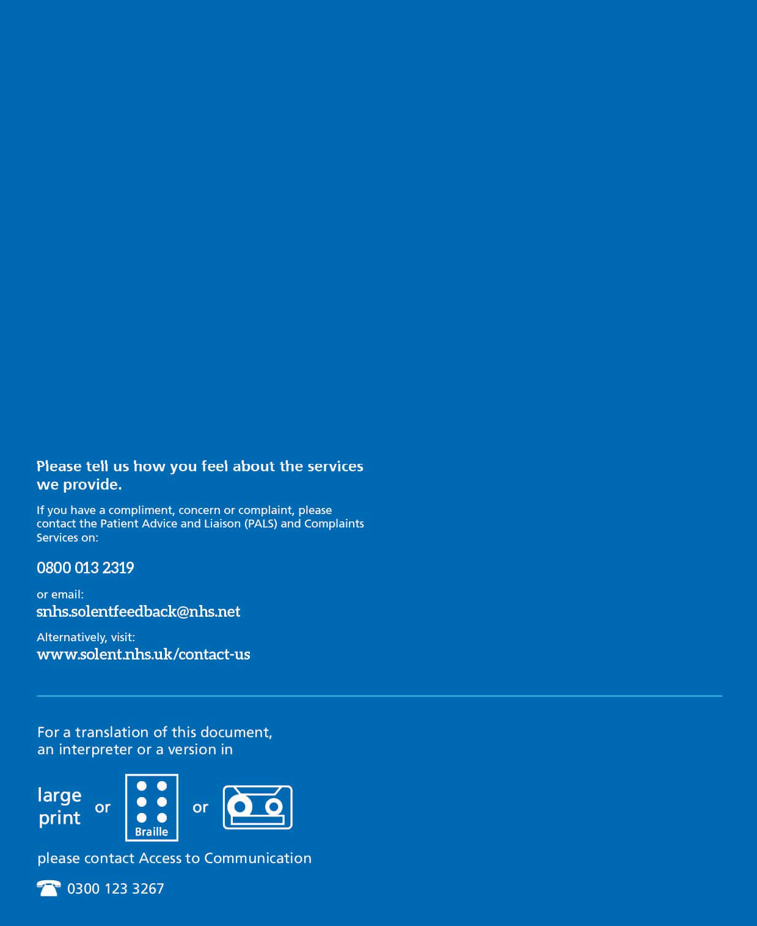

21

