|  |
| --- |
| C:\Users\baskervillej\Downloads\NHS-RGB (1).jpg |
|  |
| **Fraud and Security Management Service** |





**Fraud and Corruption Strategy**



**Solent NHS Trust**

**2021 – 2024**

**

Document Management

|  |  |
| --- | --- |
| **Distribution** | All Trust employees.  External contractors.  The public. |
| **Author:** | Colin Edwards | Local Counter Fraud Specialist for Solent NHS Trust |
| **Date:** | June 2021 |
| **Version:** | 2021 – 2024 |

Introduction

Fraud affecting the NHS is unacceptable and diverts public funds away from patient care and into the pockets of criminals. The government has made it clear that it will root out these unacceptable activities wherever they occur, in order to preserve scarce public resources and to maintain public confidence in the NHS.

We fully support the aims of the Government and the NHS Counter Fraud Authority (NHSCFA) in reducing losses to fraud and corruption to an absolute minimum. This strategy describes how we will develop and maintain its arrangements to counter fraud, bribery and corruption over the next 3 years and is aligned to the aims of the current NHSCFA strategy; our vision and strategy (March 2020) and our core values; Honesty, Everyone Counts, Accountable, Respectful and Teamwork (HEART).

We have a nominated and qualified Local Counter Fraud Specialist (LCFS), who works with us to ensure that the aims of this strategy are met and progress update reports are provided to the Chief Financial Officer (CFO), Board and Audit and Risk Committee as appropriate. The LCFS is employed by the Fraud and Security Management Service, a NHS hosted service based in Hampshire. The Fraud and Security Management Service is an intelligence-led organisation, using local and national intelligence to build a better understanding of the fraud risks faced by the NHS, encourage the reporting of fraud and develop creative, innovative and proportionate solutions to tackle fraud within the health system. The service’s management arrangements are detailed in a Service Level Agreement and as part of this agreement our CFO is a member of the Fraud and Security Management Board. The Fraud and Security Management Board is made up of the CFOs and Directors of Finance of the Local Counter Fraud Service's client organisations. It meets periodically and determines the service’s budget and strategic direction.

***Our Vision…***

“….is to provide great care, be a great place to work and provide great value for money. Fraud, bribery and corruption threaten these aims and therefore we will ensure that we use the right expertise and our workforce have the right training and take the right action in accordance with our HEART values if fraud, bribery and corruption is encountered.”

Risks and Challenges Facing the Organisation

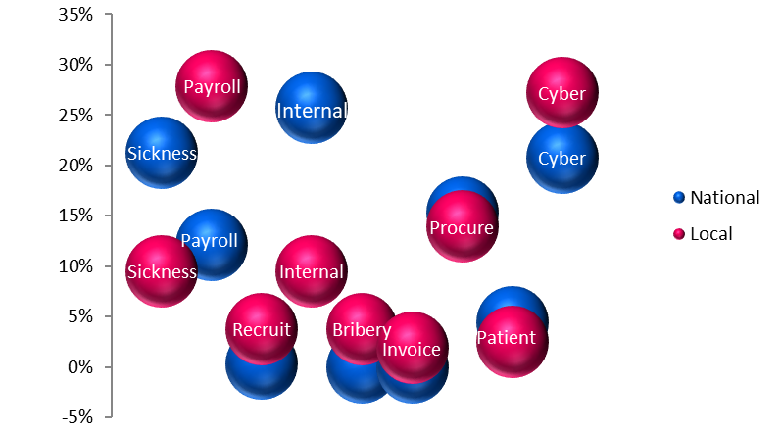Fraud risks are reviewed regularly to ensure that appropriate resource is directed to combat the highest and emerging risks. The LCFS completes a comprehensive risk assessment annually, which evaluates local and national fraud referral types and highlights the main risks and challenges facing our organisation. This appraised fraud referral types recorded with the Fraud and Security Management Service’s client base. Fraud referral types from the NHSCFA document: ‘NHSCFA fraud threats to the NHS from COVID-19’ were used to provide a national perspective.

% of cases

The fraud types are categorised into nine key fraud risk areas and eighteen detailed risks facing the organisation. The scoring matrix mirrors the matrix used by us and the risks are managed in line with our Risk Management Framework. The risk assessment is provided to and managed by the Head of Risk and Litigation in line with the requirements of our Risk Management Framework.

The risk assessment is used when drafting each year’s Fraud, Bribery and Corruption Work Plan and to determine which focussed areas of proactive work will be undertaken.

How the Fraud Landscape May Change

We remain flexible and adaptable to a changing fraud risk landscape. The risk assessments conducted by the LCFS will be regularly reviewed and will include relevant new and developing fraud and corruption risks as they are identified.

**The NHS response to the current Covid-19 pandemic** has seen new risks come to the fore, some of which may continue when the pandemic ends. Revised working arrangements may remain if they are seen as being more efficient. Increasing numbers of staff working remotely with reduced supervision creates a new fraud risk which must be assessed and managed in the coming years. Increased remote working may also impact on the effectiveness of internal controls and procedures. It is also the case that during periods of challenge for an organisation, potential frauds may go undetected due to limited levels of direct management and checking and the greater trust shown to staff. It may also be that staff are simply too busy to detect potential criminality. Referral numbers have not reduced during the pandemic and as the NHS returns to the ‘new normal’ there remains a potential for an increased number of reports of suspected frauds that had gone undetected because of the pressures of the pandemic response.

**The likely long term economic downturn and uncertainty caused by the Covid-19 pandemic** will almost certainly increase the risk of fraud and other financial crime in general. With a greater percentage of the population facing financial difficulties there is an increased risk of an individual being driven to act dishonestly as households may struggle to cope with reduced income and increasing debt. This gives a potential for more reports of staff frauds committed for financial gain, with increased numbers of working while sick cases (which is the most common staff fraud reported both locally and nationally) and other internal frauds such as deliberate financial and budget mismanagement

**Cyber-crime has become an increasing risk in recent years,** with the NHS being a target for those engaged in organised crime. A single ‘ransomware’ or ‘denial of service’ attack could result in huge financial loss and impact on the delivery of patient care. The ‘Wannacry’ ransomware attack is estimated to have cost the NHS £92 million and caused widespread disruption. In 2020 globally there was a reported ransomware attack every ten seconds and half of all businesses reported a cyber-attack during the year. CEO and Mandate Fraud attempts are becoming more refined with the use of lookalike web addresses, email addresses and company branding adding authenticity to attempts. It is likely that we will continue to be targeted by increasingly sophisticated attempts as fraudsters become more skilled.

**The Government White Paper on ‘The Future of Health and Care’** published by the Department of Health and Social Care in Feb 2021 poses a potential future fraud risk. Any organisation can be vulnerable to a higher risk of fraud and error during periods of change, with revised procedures and processes not ‘fitting’ existing methods of internal control. It is key during any period of change that our internal controls are developed and updated as part of any reorganisation. The LCFS will be involved in any consultation on changes to any internal control process to ensure that appropriate anti-fraud and corruption measures are included. At times of staff uncertainty and increased fluidity, numbers of reports of suspected fraud can fall as employees lose focus on fraudulent issues with a potential that criminal behaviour could remain undetected for longer.

These and other risks are detailed in full in the paper: ‘Fraud, Bribery and Corruption Risk Assessment - Fraud Risks and Type’ which is prepared annually and is used to inform our annual ‘Fraud, Bribery and Corruption Work Plan’, which is agreed between the Chief Financial Officer, LCFS and Audit and Risk Committee. The work plan sets out the work programme that will be undertaken by the LCFS to prevent, deter, detect and investigate instances of fraud affecting the Trust and to meet the requirements of the Government Functional Standard GovS 013: Counter Fraud. It includes detail of planned Local Proactive Detection Exercises that will be undertaken in areas of high risk.

|  |  |  |  |
| --- | --- | --- | --- |
| **What we will do** | **How we will do it** | **How it will be measured & reported** |  |

Three Year Plan and Objectives

|  |  |  |
| --- | --- | --- |
| **What we will do** | **How we will do it** | **How it will be measured & reported** |

|  |  |  |
| --- | --- | --- |
| **What we will do** | **How we will do it** | **How it will be measured & reported** |