Choking

1. Signs of Mild Choking:

- Ask the person “Are you choking?”
- It is mild choking if he:
  - answers “yes”
  - is able to speak, cough and breathe
- Encourage him to continue coughing, but do nothing else
- Wait with the person until the obstruction has cleared and they have stopped choking

2. Signs of Severe Choking:

- Ask the person “Are you choking?”
- It is severe choking if he:
  - is unable to speak or responds by nodding
  - is unable to breathe or breathing sounds wheezy
  - attempts to cough, but is unable to cough properly
  - becomes unconscious

What to do if the person is conscious and shows signs of severe choking:

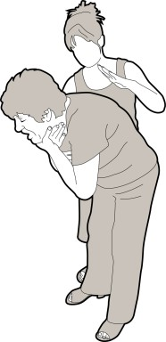
- Give up to 5 back slaps

  - Stand to the side and slightly behind the person
  - Support the chest with one hand
  - Lean the person forwards so that when the obstructing object is dislodged it comes out of the mouth rather than goes further down the airway
  - Give up to 5 sharp slaps between the shoulder blades with the heel of your hand
  - Check to see if each slap has relieved the airway obstruction. The aim is to relieve the obstruction with each slap rather than necessarily give all 5

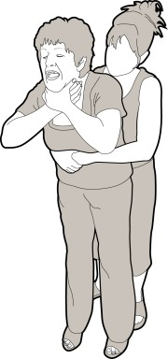
- If 5 back slaps fail to remove the airway obstruction, give up to 5 abdominal thrusts

  - Stand behind the person and put both arms around the upper part of the stomach
  - Lean the person forwards
  - Clench your fist and place it above the belly button
  - Grasp this hand with your other hand and pull sharply inwards and upwards
  - Repeat up to 5 times

- If the obstruction is still not removed, continue alternating 5 back slaps with 5 abdominal thrusts

What to do if a person becomes unconscious:

- Support the person carefully to the ground
- Immediately call an ambulance
- Begin Basic Life Support with Cardio Pulmonary Resuscitation (CPR)

Explanatory Notes:

- Following successful treatment for choking, some foreign material may remain in the throat or lungs which could cause complications later. Anyone with a persistent cough, difficulty swallowing, or with the sensation of an object still being stuck in the throat should therefore be referred to a Doctor for a medical opinion

- Abdominal thrusts can cause internal injuries and anyone who has received abdominal thrusts should be examined by a Doctor.

Information created / adapted by Solent NHS Trust Adult Speech and Language Therapy (East) 0300 123 3932

