GENDER PAY GAP REPORT 2018
31st March 2019

Background

Under the Equality Act 2010 (Gender pay Gap Information) Regulations 2017 every employer who has 250 or more employees is required to publish their gender pay gap for workers in post as at the 31st March each year, which has to be published by the 30th March the following year.
Calculating a gender pay gap involves carrying out six calculations that shows the difference between the average earnings of men and women within the Trust. No personal data of any individual is included in this report.
This report should not be confused with an equal pay report which is based on equal pay for work of equal value.

Average Rates of Pay
Group | Average Hourly Rate of Pay | Average Annual Bonus Payment*
Male | £ 18.26 | £ 13,381.97
Female | £ 15.45 | £ 7,632.07
Percentage variance | 15.3% | 42.9%
*average calculation based on those receiving a bonus payment.
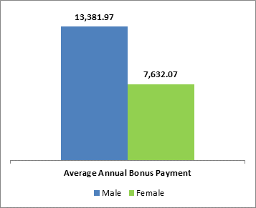
Key Points
- The average hourly rate of pay is calculated from a specific pay period, in this case March 2018. The hourly rate if calculated for each employee based on “ordinary pay” which includes basic pay after any salary sacrifice deduction for childcare vouchers or nursery fees direct has been deducted, recruitment and retention payments, enhancements, on-call payments, additional hours/sessions, pay protection payments, additional responsibility payments, essential user for travel allowances. It does not include overtime, additional programme activities, emergency return to work payments for full time staff, pay in lieu of notice, redundancy pay, pay in lieu of annual leave, travel or subsistence payments.

- The percentage variance for the average hourly rate of pay is just over 15% in 2018-19 (just under 15% in 2017-18). This calculation is based on the average hourly rate of 3104 female staff compared to 478 male staff; as 88% (87% in 2016/17) of staff making use of the salary sacrifice arrangements are female the variance in pay is to be expected. Whilst this does not affect the median pay it does have an impact on the average pay shown above.

- As an NHS organisation the only pay elements that fall under the bonus pay criteria are clinical excellence awards which are only paid to Medical and Dental consultants

- The percentage variance for the annual bonus payments is just under 43% which is a decrease of 15% since last year (57.31% in 2016/17). Although this may seem high there are an equal number of male and female staff receiving a bonus, but many of the female employees are part time, and the majority of National Awards which are paid at the highest levels were held by male employees.

Median Rates of Pay
Group | Median Hourly Rate of Pay | Median Annual Bonus Payment*
Male | £ 14.13 | £ 9,040.50
Female | £ 14.07 | £ 4,218.94
Percentage variance | 0.4% | 53.3%
* median calculation based on those receiving a bonus payment.
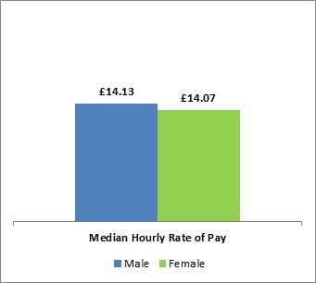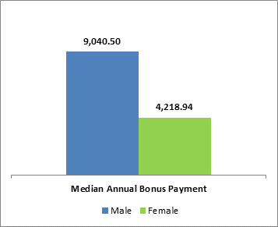
Key Points:
- The median hourly rate of pay is calculated from a specific pay period, in this case March 2018. The median rate is calculated by selecting the average hourly rate at the mid-point for each gender group.

- The percentage variance for median hourly rate is under 1%, within this Organisation which equates to less than 10p per hour (6p in2018/19, compared to 9p 2017/18). This is significantly lower than the average pay as shown above due to the impact of salary sacrifice arrangements.

- As with the median hourly rate of pay, the median bonus payment is the mid-point of the annual bonuses in payment.

- The percentage variance of the median bonus is under 54%, compared to 57.31% in 2017/18. As stated in the average rates of pay, the number of employees receiving a Clinical Excellence awards are equal by gender. The pay elements that are used in this calculation are awarded as a result of recognition of excellence in practice over and above contractual requirements and have no gender bias. However they are paid on a pro rata basis for part time staff and as many of the female employees are part time this does impact median amount in payment.

Proportion of staff receiving a bonus
Gender | Total Employee's paid bonus | Total number of employees in Trust within year | Percentage
Male | 13 | 548 | 2.3%
Female | 13 | 3513 | 0.3%

Key points:
- This calculation expresses the number of staff receiving bonus pay as a percentage of the total number of staff in each gender group.

- As previously stated bonus pay elements are awarded as a result of recognition of excellent practice over and above contractual requirements, and have no gender bias. Clinical excellence awards are split into local and national awards. The national awards are significantly higher than a local award, so where one or more is in payment this will show a higher payment for that particular gender.

- It is only consultants who are in receipt of clinical excellence awards that receive payments classified as bonus payments. Less than 2% of all staff employed in the year are eligible to receive a clinical excellence award and as a result the relevance of this indicator is less significant as bonus pay applies to less than 1% of the staff employed.

Quartile Analysis of Hourly Pay Rates
Gender | Lower | Lower Middle | Upper Middle | Upper | Trust
Male | 119 | 119 | 82 | 158 | 478
Female | 876 | 677 | 814 | 737 | 3104
Total | 995 | 796 | 896 | 895 | 3,582
Percentage Male | 12.0% | 15.0% | 9.2% | 17.6% | 13.34%
Percentage Female | 88.0% | 85.0% | 90.8% | 82.4% | 86.6%

Key Points:
- In order to create the quartile information all staff are sorted by their hourly rate of pay, this list is then split into four equal parts. Where a particular hourly pay rate falls into two different quartiles, the total gender of staff on that rate of pay is distributed evenly across the quartiles.

- It is important that when reviewing the quartile information the types of roles available within the organisation and the different gender splits that occur within specific roles

- The highest variances for the quartiles when compared with the overall Trust value are in the upper middle and upper quartiles.

- There is a lower proportion of male staff in the upper middle quartile (9.2%% down from 9.89% last year) The staff range from band 1 housekeeping assistants with enhancements, to some band 7 staff with salary sacrifices. The majority of staff are band 5 and 6 staff

- In the last year there has been a slight increase in the number of male staff in the upper quartile (17.6% compared to 17.3% last year). The higher proportion of male staff in the upper quartile includes band 5 and 6 staff with enhancements and the majority of staff above this band within the organisation. It does reflect the different gender split in managerial roles within the Trust.

- The lower and lower middle are representative of the Trust as a whole with less than a 1.5% variance. In the last year there has been a slight reduction in the number of male staff in the lower quartile 12% compared to 12.47% last year, but the number in the lower middle quartile has increased from 14.49% to 15% The lower quartile includes Apprentices for the first time, and band 1 to band 3 staff, whereas the lower middle quartile includes band 2 to band 4 and some band 5 staff with salary sacrifices.

